**MODERN ACADEMY**

**FOR ENGINEERING & TECHNOLOGY**

**Computer Department**

**Academic Year 2021/2022**

**December 2022**

**Toolbox Documentation**

**Course Title: Digital image processing**

**Course Code: CMPN332**

|  |  |
| --- | --- |
| Name | Mohamed Magdy Mohamed |
| Section | **1** |
| ID | **4190827** |
| Dr | **Sabry Mohamed Abdelmoaty** |

Content:

1. Installing
2. Initialize
3. Source Code
4. Final View of the program
5. Every button and component in the program

First Installing the program:

1. These is the link of python to install first

<https://www.python.org/ftp/python/3.11.1/python-3.11.1-amd64.exe>

1. Then setup program by clicking next to begin setup process.
2. Install anaconda navigator and there is the link

<https://repo.anaconda.com/archive/Anaconda3-2022.10-Windows-x86_64.exe>

1. Then setup anaconda by clicking next until start program

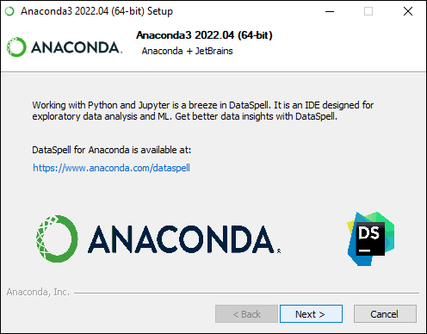

1. Install visual studio code

<https://az764295.vo.msecnd.net/stable/1ad8d514439d5077d2b0b7ee64d2ce82a9308e5a/VSCodeUserSetup-x64-1.74.1.exe>

1. Then setup
2. Open visual studio code from anaconda by clicking on launch visual studio code

1. Click connect in Anaconda to download all libraries and updates

Second initializing the program:

import statistics

from tkinter import DISABLED, HORIZONTAL, NORMAL, NW, Entry, Button, Canvas, Label, Scale, StringVar, Text, messagebox , Tk, filedialog, PhotoImage, RAISED

import tkinter as tk

from tkinter.font import BOLD

from tkinter.tix import *

import cv2

import PIL.Image, PIL.ImageTk

from tkinter.messagebox import showinfo

from tkinter.ttk import Combobox

import numpy as np

from numpy import asarray

import os

from matplotlib import pyplot as plt

Third Source Code:

def flipingHeFunction():

    global image

    global photo

    arr = np.zeros((image.shape[0],image.shape[1]))

    for row in range(image.shape[0]) :

        for col in range(image.shape[1]):

            arr[row,col] = image[row,(image.shape[1]-col-1)]

    for row in range(image.shape[0]) :

        for col in range(image.shape[1]):

            image[row,col] = arr[row,col]

    photo = PIL.ImageTk.PhotoImage(image = PIL.Image.fromarray(image))

    canvas.create_image(0, 0, image=photo, anchor=NW)

def flipingVeFunction():

    global image

    global photo

    arr = np.zeros((image.shape[0],image.shape[1]))

    for row in range(image.shape[0]) :

        for col in range(image.shape[1]):

            arr[row,col] = image[(image.shape[0]-row-1),col]

    for row in range(image.shape[0]) :

        for col in range(image.shape[1]):

            image[row,col] = arr[row,col]

    photo = PIL.ImageTk.PhotoImage(image = PIL.Image.fromarray(image))

    canvas.create_image(0, 0, image=photo, anchor=NW)

# Rotate Function

def rotBtn():

    global image

    global photo

    image = cv2.rotate(image,cv2.ROTATE_90_CLOCKWISE)

    photo = PIL.ImageTk.PhotoImage(image = PIL.Image.fromarray(image))

    canvas.create_image(0, 0, image=photo, anchor=NW)

# Translate UP Function

def trUpBtn():

    global image

    global photo

    M = np.float32([[1,0,0],[0,1,10]])

    image =cv2.warpAffine(image,M,(image.shape[1],image.shape[0]))

    photo = PIL.ImageTk.PhotoImage(image = PIL.Image.fromarray(image))

    canvas.create_image(0 , 0 ,image=photo ,anchor=NW)

# Translation Dwon Function

def trDwonBtn():

    global image

    global photo

    M = np.float32([[1,0,0],[0,1,-10]])

    image =cv2.warpAffine(image,M,(image.shape[1],image.shape[0]))

    photo = PIL.ImageTk.PhotoImage(image = PIL.Image.fromarray(image))

    canvas.create_image(0 , 0 ,image=photo ,anchor=NW)

# TranslateLeft

def details():

    global image

    global photo

    print("img", image)

    smallest = np.amin(image)

    biggest = np.amax(image)

    print("smallest", smallest)

    print("biggest", biggest)

    avarage = np.average(image)

    print("avarage", avarage)

    image = asarray(image)

    orignalImg = image

    photo = PIL.ImageTk.PhotoImage(image=PIL.Image.fromarray(image))

    canvas.create_image(0, 0, image=photo, anchor=NW)

def Tleft():

    global image

    global photo

    M = np.float32([[1, 0, 10],[0, 1, 0]])

    image = cv2.warpAffine(image, M, (image.shape[1], image.shape[0]))

    photo = PIL.ImageTk.PhotoImage(image = PIL.Image.fromarray(image))

    canvas.create_image(0, 0, image=photo, anchor=NW)

#TranslateRight

def Treight():

    global image

    global photo

    M = np.float32([[1, 0, -10],[0, 1, 0]])

    image = cv2.warpAffine(image, M, (image.shape[1], image.shape[0]))

    photo = PIL.ImageTk.PhotoImage(image = PIL.Image.fromarray(image))

    canvas.create_image(0, 0, image=photo, anchor=NW)

#Affine transformation

def affineTransform(val):

    global image

    global photo

    point_1 = np.float32([[0, 0], [0, image.shape[1]], [image.shape[0], image.shape[1]]])

    point_2 = np.float32([[val, 0], [0, image.shape[1]], [image.shape[0], image.shape[1]]])

    M = cv2.getAffineTransform(point_1, point_2)

    image = cv2.warpAffine(image, M, (image.shape[1], image.shape[0]))

    photo = PIL.ImageTk.PhotoImage(image = PIL.Image.fromarray(image))

    canvas.create_image(0, 0, image=photo, anchor=NW)

# searing

def Sharping1():

    global image

    global photo

    kernal_shearing = np.array([[-1, -1, -1],[-1, 9, -1],[-1, -1, -1]])

    image = cv2.filter2D(image, -1, kernal_shearing)

    photo = PIL.ImageTk.PhotoImage(image = PIL.Image.fromarray(image))

    canvas.create_image(0, 0, image=photo, anchor=NW)

def Sharping2():

    global image

    global photo

    kernal_shearing = np.array([[1, 1, 1],[1, -7, 1],[1, 1, 1]])

    image = cv2.filter2D(image, -1, kernal_shearing)

    photo = PIL.ImageTk.PhotoImage(image = PIL.Image.fromarray(image))

    canvas.create_image(0, 0, image=photo, anchor=NW)

def Sharping3():

    global image

    global photo

    kernal_shearing = np.array([[-1,-1,-1,-1,-1],

                             [-1,2,2,2,-1],

                             [-1,2,8,2,-1],

                             [-1,2,2,2,-1],

                             [-1,-1,-1,-1,-1]]) / 8.0

    image = cv2.filter2D(image, -1, kernal_shearing)

    photo = PIL.ImageTk.PhotoImage(image = PIL.Image.fromarray(image))

    canvas.create_image(0, 0, image=photo, anchor=NW)

def scaleOfMotion(val):

    global image

    global photo

    size = motion_blur_scale.get()

    kernal_motion_blur = np.zeros((size,size))

    kernal_motion_blur[int((size-1)/2), :] = np.ones(size)

    kernal_motion_blur = kernal_motion_blur/size

    image = cv2.filter2D(image, -1, kernal_motion_blur)

    photo = PIL.ImageTk.PhotoImage(image = PIL.Image.fromarray(image))

    canvas.create_image(0, 0, image=photo, anchor=NW)

def TransformCombobox(event):

    global image

    global photo

    transform = event.widget.get()

    if transform == 'Dilation':

        binr = cv2.threshold(image, 0, 255, cv2.THRESH_BINARY+cv2.THRESH_OTSU)[1]

        kernel = np.ones((3, 3), np.uint8)

        invert = cv2.bitwise_not(binr)

        image = cv2.dilate(invert, kernel, iterations=1)

    elif transform == 'Erosion':

        binr = cv2.threshold(image, 0, 255, cv2.THRESH_BINARY+cv2.THRESH_OTSU)[1]

        kernel = np.ones((5, 5), np.uint8)

        invert = cv2.bitwise_not(binr)

        image = cv2.erode(invert,kernel,iterations=1)

    elif transform == 'Opening':

        binr = cv2.threshold(image, 0, 255, cv2.THRESH_BINARY+cv2.THRESH_OTSU)[1]

        kernel = np.ones((3, 3), np.uint8)

        image = cv2.morphologyEx(binr, cv2.MORPH_OPEN, kernel, iterations=1)

    elif transform == 'Closing':

        binr = cv2.threshold(image, 0, 255, cv2.THRESH_BINARY+cv2.THRESH_OTSU)[1]

        kernel = np.ones((3, 3), np.uint8)

        image = cv2.morphologyEx(binr, cv2.MORPH_CLOSE, kernel, iterations=1)

    elif transform == 'Gradient':

        binr = cv2.threshold(image, 0, 255, cv2.THRESH_BINARY+cv2.THRESH_OTSU)[1]

        kernel = np.ones((3, 3), np.uint8)

        invert = cv2.bitwise_not(binr)

        image = cv2.morphologyEx(invert, cv2.MORPH_GRADIENT ,kernel)

    elif transform == 'Top Hat':

        binr = cv2.threshold(image, 0, 255, cv2.THRESH_BINARY+cv2.THRESH_OTSU)[1]

        kernel = np.ones((13, 13), np.uint8)

        image = cv2.morphologyEx(binr, cv2.MORPH_TOPHAT ,kernel)

    elif transform == 'Black Hat':

        binr = cv2.threshold(image, 0, 255, cv2.THRESH_BINARY+cv2.THRESH_OTSU)[1]

        kernel = np.ones((5, 5), np.uint8)

        invert = cv2.bitwise_not(binr)

        image = cv2.morphologyEx(invert, cv2.MORPH_BLACKHAT ,kernel)

    photo = PIL.ImageTk.PhotoImage(image = PIL.Image.fromarray(image))

    canvas.create_image(0, 0, image=photo, anchor=NW)

def FilterCombobox(event):

    global image

    global photo

    filters = event.widget.get()

    if filters == 'Gray-scale':

        motion_blur_scale['state'] = DISABLED

        disableShearingBtn()

        image = cv2.cvtColor(image,cv2.COLOR_BGR2GRAY)

    elif filters == 'Blur 3X3':

        motion_blur_scale['state'] = DISABLED

        disableShearingBtn()

        kernal_3X3 = np.ones((3,3), np.float32) / 9

        image = cv2.filter2D(image, -1, kernal_3X3)

    elif filters == 'Blur 5X5':

        motion_blur_scale['state'] = DISABLED

        disableShearingBtn()

        kernal_5X5 = np.ones((5,5), np.float32) / 25

        image = cv2.filter2D(image, -1, kernal_5X5)

    elif filters == 'None':

        motion_blur_scale['state'] = DISABLED

        disableShearingBtn()

        kernal_identifiy = np.array([[0, 0, 0],[0, 1, 0],[0, 0, 0]])

        image = cv2.filter2D(image, -1, kernal_identifiy)

    elif filters == 'Motion-blur':

        motion_blur_scale['state'] = NORMAL

        disableShearingBtn()

    elif filters == 'sharping':

        motion_blur_scale['state'] = DISABLED

        searingBt1['state'] = NORMAL

        searingBt2['state'] = NORMAL

        searingBt3['state'] = NORMAL

    elif filters == 'Gaussian blur':

        motion_blur_scale['state'] = DISABLED

        disableShearingBtn()

        image = cv2.GaussianBlur(image,(9,9),0)

    elif filters == 'Median blur':

        motion_blur_scale['state'] = DISABLED

        disableShearingBtn()

        image = cv2.medianBlur(image,9)

    elif filters == 'Bilateral filter':

        motion_blur_scale['state'] = DISABLED

        disableShearingBtn()

        image = cv2.bilateralFilter(image,10,25,25)

    photo = PIL.ImageTk.PhotoImage(image = PIL.Image.fromarray(image))

    canvas.create_image(0, 0, image=photo, anchor=NW)

def disableShearingBtn():

    searingBt1['state'] = DISABLED

    searingBt2['state'] = DISABLED

    searingBt3['state'] = DISABLED

def edgeDetectHor():

    global image

    global photo

    kernal = np.array([[-1, 0, 1],[-2, 0, 2],[-1, 0, 1]])

    image = cv2.filter2D(image, -1, kernal)

    photo = PIL.ImageTk.PhotoImage(image = PIL.Image.fromarray(image))

    canvas.create_image(0, 0, image=photo, anchor=NW)

def edgeDetectVer():

    global image

    global photo

    kernal = np.array([[1, 2, 1],[0, 0, 0],[-1, -2, -1]])

    image = cv2.filter2D(image, -1, kernal)

    photo = PIL.ImageTk.PhotoImage(image = PIL.Image.fromarray(image))

    canvas.create_image(0, 0, image=photo, anchor=NW)

def edgeDetectLaplacian():

    global image

    global photo

    image = cv2.Laplacian(image,cv2.CV_64F)

    photo = PIL.ImageTk.PhotoImage(image = PIL.Image.fromarray(image))

    canvas.create_image(0, 0, image=photo, anchor=NW)

def edgeDetectCanny():

    global image

    global photo

    if(minInput.get() == '' or maxInput.get() == ''):

        messagebox.showwarning(title="Warning", message="Enter Min Value or Max Value of threshold")

    elif(float(maxInput.get()) <= float(minInput.get())):

        messagebox.showwarning(title="Warning", message="The max Threshold must bigger then min threshold")

    else:

        image = cv2.Canny(image, float(minInput.get()), float(maxInput.get()))

        photo = PIL.ImageTk.PhotoImage(image = PIL.Image.fromarray(image))

        canvas.create_image(0, 0, image=photo, anchor=NW)

def NegativeFunction():

    global image

    global photo

    for row in range(image.shape[0]):

        for col in range(image.shape[1]):

            image[row,col] =  255 - image[row,col]

    photo = PIL.ImageTk.PhotoImage(image = PIL.Image.fromarray(image))

    canvas.create_image(0, 0, image=photo, anchor=NW)

def mergeingImages():

    global photo2

    global image

    global photo

    arr = np.zeros((image.shape[0],image.shape[1]))

    fln2 = filedialog.askopenfilename(initialdir=os.getcwd(),title="Select image", filetypes=(("JPG File","*.jpg"),("PNG File","*.png"),("All Files","*.*")))

    image2 = PIL.Image.open(fln2)

    image2 = asarray(image2)

    if image2.shape[0] > 50 or image2.shape[1] > 50:

        dim2 = (50,50)

        image2 = cv2.resize(image2,dim2, interpolation = cv2.INTER_AREA)

    photo2 = PIL.ImageTk.PhotoImage(image = PIL.Image.fromarray(image2))

    if len(image.shape) == 3:

        image = cv2.cvtColor(image,cv2.COLOR_RGB2GRAY)

    image2 = cv2.cvtColor(image2,cv2.COLOR_RGB2GRAY)

    dim = (image.shape[1],image.shape[0])

    image2 = cv2.resize(image2,dim, interpolation = cv2.INTER_AREA)

    for row in range(image.shape[0]):

        for col in range(image.shape[1]):

            arr[row,col] = image[row,col] * 0.8 + image2[row,col] * 0.2

    image = arr

    photo = PIL.ImageTk.PhotoImage(image = PIL.Image.fromarray(image))

    canvas.create_image(0, 0, image=photo, anchor=NW)

def resets():

    global image

    global orignalImg

    global finalEdit

    global photo

    image = orignalImg

    finalEdit = orignalImg

    photo = PIL.ImageTk.PhotoImage(image = PIL.Image.fromarray(image))

    canvas.create_image(0, 0, image=photo, anchor=NW)

def uploadImage():

    global image

    global photo

    global orignalImg

    global finalEdit

    fln = filedialog.askopenfilename(initialdir=os.getcwd(),title="Select image", filetypes=(("JPG File","*.jpg"),("PNG File","*.png"),("All Files","*.*")))

    image = PIL.Image.open(fln)

    image = asarray(image)

    if image.shape[0] > 700 or image.shape[1] > 600:

        dim = (700,600)

        image = cv2.resize(image,dim, interpolation = cv2.INTER_AREA)

    orignalImg = image

    finalEdit = image

    photo = PIL.ImageTk.PhotoImage(image = PIL.Image.fromarray(image))

    canvas.create_image(0, 0, image=photo, anchor=NW)

def equalizeHist():

    global image

    global photo

    if(len(image.shape)<3):

        image = cv2.equalizeHist(image)

    elif len(image.shape)==3:

      image = cv2.cvtColor(image, cv2.COLOR_BGR2YUV)

      image[:,:,0] = cv2.equalizeHist(image[:,:,0])

      image = cv2.cvtColor(image, cv2.COLOR_YUV2BGR)

    photo = PIL.ImageTk.PhotoImage(image = PIL.Image.fromarray(image))

    canvas.create_image(0, 0, image=photo, anchor=NW)

def hisPlot():

    global image

    plt.hist(image.ravel(),256,[0,256],color ='tab:green')

    plt.show()

def Saving():

    global finalEdit

    global image

    global photo

    finalEdit = image

    cv2.imwrite('Edit.jpg',finalEdit)

    messagebox.showinfo(title="Saving process", message="Saving Done Correctly")

    photo = PIL.ImageTk.PhotoImage(image = PIL.Image.fromarray(image))

    canvas.create_image(0, 0, image=photo, anchor=NW)

def restoreBtn():

    global image

    global photo

    finalEdit = cv2.imread("Edit.jpg",0)

    image = finalEdit

    photo = PIL.ImageTk.PhotoImage(image = PIL.Image.fromarray(image))

    canvas.create_image(0, 0, image=photo, anchor=NW)

def thresholdBtn():

    global finalEdit

    global image

    global photo

    if(minInput.get() == '' or maxInput.get() == ''):

        messagebox.showwarning(title="Warning", message="Enter Min Value or Max Value of threshold")

    elif(float(maxInput.get()) <= float(minInput.get())):

        messagebox.showwarning(title="Warning", message="The max Threshold must bigger then min threshold")

    else:

        ret1, thresh1 = cv2.threshold(image, float(minInput.get()), float(maxInput.get()), cv2.THRESH_BINARY_INV)

        image = thresh1

        photo = PIL.ImageTk.PhotoImage(image = PIL.Image.fromarray(image))

        canvas.create_image(0, 0, image=photo, anchor=NW)

def bitPlaneCombobox(even):

    global image

    global photo

    val = even.widget.get()

    lst = []

    for row in range(image.shape[0]):

        for col in range(image.shape[1]):

            lst.append(np.binary_repr(image[row][col] ,width=8))

    if val == '128':

        image = (np.array([int(i[0]) for i in lst],dtype = np.uint8) * 128).reshape(image.shape[0],image.shape[1])

    elif val == '64':

        image = (np.array([int(i[1]) for i in lst],dtype = np.uint8) * 64).reshape(image.shape[0],image.shape[1])

    elif val == '32':

        image = (np.array([int(i[2]) for i in lst],dtype = np.uint8) * 32).reshape(image.shape[0],image.shape[1])

    elif val == '16':

        image = (np.array([int(i[3]) for i in lst],dtype = np.uint8) * 16).reshape(image.shape[0],image.shape[1])

    elif val == '8':

        image = (np.array([int(i[4]) for i in lst],dtype = np.uint8) * 8).reshape(image.shape[0],image.shape[1])

    elif val == '4':

        image = (np.array([int(i[5]) for i in lst],dtype = np.uint8) * 4).reshape(image.shape[0],image.shape[1])

    elif val == '2':

        image = (np.array([int(i[6]) for i in lst],dtype = np.uint8) * 2).reshape(image.shape[0],image.shape[1])

    elif val == '1':

        image = (np.array([int(i[7]) for i in lst],dtype = np.uint8) * 1).reshape(image.shape[0],image.shape[1])

    photo = PIL.ImageTk.PhotoImage(image = PIL.Image.fromarray(image))

    canvas.create_image(0, 0, image=photo, anchor=NW)

def logBtn():

    global image

    global photo

    c = 255 / np.log( 1 + np.max(image))

    logImage = c * (np.log(image + 1))

    image = np.array(logImage, dtype=np.uint8)

    photo = PIL.ImageTk.PhotoImage(image = PIL.Image.fromarray(image))

    canvas.create_image(0, 0, image=photo, anchor=NW)

def contourBtn():

    global image

    global photo

    if(minInput.get() == '' or maxInput.get() == ''):

        m = statistics.mean(image.ravel())

        sd = statistics.stdev(image.ravel())

        ret1, thresh1 = cv2.threshold(image, m-sd, m+sd, cv2.THRESH_BINARY)

        contours, hierarchy = cv2.findContours(thresh1, cv2.RETR_TREE, cv2.CHAIN_APPROX_NONE)

        image = cv2.cvtColor(image, cv2.COLOR_BGR2RGB)

        cv2.drawContours(image, contours, -1,color=(0,255,0),thickness=3)

        print("the number of object is:",str(len(contours)))

        photo = PIL.ImageTk.PhotoImage(image = PIL.Image.fromarray(image))

        canvas.create_image(0, 0, image=photo, anchor=NW)

    elif(float(maxInput.get()) <= float(minInput.get())):

        messagebox.showwarning(title="Warning", message="The max Threshold must bigger then min threshold")

    else:

        ret1, thresh1 = cv2.threshold(image, float(minInput.get()), float(maxInput.get()), cv2.THRESH_BINARY)

        contours, hierarchy = cv2.findContours(thresh1, cv2.RETR_TREE, cv2.CHAIN_APPROX_NONE)

        image = cv2.cvtColor(image, cv2.COLOR_BGR2RGB)

        cv2.drawContours(image, contours, -1,color=(0,255,0),thickness=3)

        print("the number of object is:",str(len(contours)))

        photo = PIL.ImageTk.PhotoImage(image = PIL.Image.fromarray(image))

        canvas.create_image(0, 0, image=photo, anchor=NW)

def matchBtnfun():

    global image

    global photo

    fln2 = filedialog.askopenfilename(initialdir=os.getcwd(),title="Select image", filetypes=(("JPG File","*.jpg"),("PNG File","*.png"),("All Files","*.*")))

    image2 = PIL.Image.open(fln2)

    image2 = asarray(image2)

    orb = cv2.ORB_create()

    keypoints1, descriptors1 = orb.detectAndCompute(image,None)

    keypoints2, descriptors2 = orb.detectAndCompute(image2,None)

    bf_matcher = cv2.BFMatcher(cv2.NORM_HAMMING, crossCheck=True)

    bf_matches = bf_matcher.match(descriptors1, descriptors2)

    bf_matches = sorted(bf_matches, key=lambda x: x.distance)

    result = cv2.drawMatches(image, keypoints1, image2, keypoints2, bf_matches[:50], None)

    cv2.imshow("Match Points",result)

    cv2.waitKey(0)

def powerCombobox(even):

    global image

    global photo

    val = even.widget.get()

    print(val)

    if val == '0.1':

        arr = np.array(255*(image/255)**0.1,dtype='uint8')

    elif val == '0.5':

        arr = np.array(255*(image/255)**0.5,dtype='uint8')

    elif val == '1.2':

        arr = np.array(255*(image/255)**1.2,dtype='uint8')

    elif val == '2.2':

        arr = np.array(255*(image/255)**2.2,dtype='uint8')

    cv2.normalize(arr,arr,0,255,cv2.NORM_MINMAX)

    cv2.convertScaleAbs(arr,arr)

    image = arr

    photo = PIL.ImageTk.PhotoImage(image = PIL.Image.fromarray(image))

    canvas.create_image(0, 0, image=photo, anchor=NW)

def digonalSobel():

    global image

    global photo

    kernal = np.array([[2,1,0],[1,0,-1],[0,-1,-2]])

    image = cv2.filter2D(image, -1 , kernal)

    photo = PIL.ImageTk.PhotoImage(image = PIL.Image.fromarray(image))

    canvas.create_image(0, 0, image=photo, anchor=NW)

def FullsobelFun():

    global image

    global photo

    kernal_1 = np.array([[1,0,-1],[2,0,-2],[1,0,-1]])

    kernal_2 = np.array([[1,2,1],[0,0,0],[-1,-2,-1]])

    kernal_3 = np.array([[2,1,0],[1,0,-1],[0,-1,-2]])

    vertical = cv2.filter2D(image, -1 , kernal_1)

    herizontal = cv2.filter2D(image, -1 , kernal_2)

    digonal = cv2.filter2D(image, -1 , kernal_3)

    dst_1 = cv2.addWeighted(vertical,1,herizontal,1,0.0)

    image = cv2.addWeighted(dst_1,1,digonal,1,0.0)

    photo = PIL.ImageTk.PhotoImage(image = PIL.Image.fromarray(image))

    canvas.create_image(0, 0, image=photo, anchor=NW)

def grayMethod():

    global image

    global photo

    if minInputGray.get() == '' or maxInputGray.get() == '':

        m = statistics.mean(image.ravel())

        med = statistics.median(image.ravel())

        h,w = image.shape

        for row in range(h):

            for col in range(w):

                if m > image[row][col] and med < image[row][col]:

                    image[row][col] = 255

        photo = PIL.ImageTk.PhotoImage(image = PIL.Image.fromarray(image))

        canvas.create_image(0, 0, image=photo, anchor=NW)

    elif int(minInputGray.get()) >= int(maxInputGray.get()):

        messagebox.showwarning(title="Warning", message="The max gray level must bigger then min gray level")

    else:

        h,w = image.shape

        for row in range(h):

            for col in range(w):

                if int(maxInputGray.get()) > image[row][col] and int(minInputGray.get()) < image[row][col]:

                    image[row][col] = 255

        photo = PIL.ImageTk.PhotoImage(image = PIL.Image.fromarray(image))

        canvas.create_image(0, 0, image=photo, anchor=NW)

def lowFreq():

    global image

    global photo

    if frequancyFilterInput.get() == '':

        r = 60

    else:

        r = int(frequancyFilterInput.get())

    rows,cols = image.shape

    H = np.zeros((rows,cols),dtype=np.float32)

    for row in range(rows):

        for col in range(cols):

            D = np.sqrt((row-rows/2)**2 + (col-cols/2)**2)

            if D <= r:

                H[row,col] = 1

            else:

                H[row,col] = 0

    f = np.fft.fft2(image)

    f_shifted = np.fft.fftshift(f)

    plt.figure(1)

    plt.imshow(np.log1p(np.abs(f_shifted)),cmap='gray')

    plt.show()

    LPF = f_shifted * H

    plt.figure(2)

    plt.imshow(np.log1p(np.abs(LPF)),cmap='gray')

    plt.show()

    reverse = np.fft.ifftshift(LPF)

    generalLPF = np.abs(np.fft.ifft2(reverse))

    image = generalLPF

    photo = PIL.ImageTk.PhotoImage(image = PIL.Image.fromarray(image))

    canvas.create_image(0, 0, image=photo, anchor=NW)

def highFreq():

    global image

    global photo

    if frequancyFilterInput.get() == '':

        r = 60

    else:

        r = int(frequancyFilterInput.get())

    rows,cols = image.shape

    H = np.zeros((rows,cols),dtype=np.float32)

    for row in range(rows):

        for col in range(cols):

            D = np.sqrt((row-rows/2)**2 + (col-cols/2)**2)

            if D <= r:

                H[row,col] = 0

            else:

                H[row,col] = 1

    f = np.fft.fft2(image)

    f_shifted = np.fft.fftshift(f)

    plt.figure(1)

    plt.imshow(np.log1p(np.abs(f_shifted)),cmap='gray')

    plt.show()

    HPF = f_shifted * H

    plt.figure(2)

    plt.imshow(np.log1p(np.abs(HPF)),cmap='gray')

    plt.show()

    reverse = np.fft.ifftshift(HPF)

    generalLPF = np.abs(np.fft.ifft2(reverse))

    image = generalLPF

    photo = PIL.ImageTk.PhotoImage(image = PIL.Image.fromarray(image))

    canvas.create_image(0, 0, image=photo, anchor=NW)

def small():

    global image

    global photo

    image=cv2.resize(image,None,fx=0.75,fy=0.75)

    photo = PIL.ImageTk.PhotoImage(image = PIL.Image.fromarray(image))

    canvas.create_image(0, 0, image=photo, anchor=NW)

def large():

    global image

    global photo

    image=cv2.resize(image,None,fx=2,fy=2,interpolation=cv2.INTER_CUBIC)

    photo = PIL.ImageTk.PhotoImage(image = PIL.Image.fromarray(image))

    canvas.create_image(0, 0, image=photo, anchor=NW)

def add():

    global image

    global photo

    M = np.ones(image.shape, dtype="uint8") * 100

    image=cv2.add(image,M)

    photo = PIL.ImageTk.PhotoImage(image = PIL.Image.fromarray(image))

    canvas.create_image(0, 0, image=photo, anchor=NW)

def sub():

    global image

    global photo

    M = np.ones(image.shape, dtype="uint8") * 100

    image=cv2.subtract(image,M)

    photo = PIL.ImageTk.PhotoImage(image = PIL.Image.fromarray(image))

    canvas.create_image(0, 0, image=photo, anchor=NW)

def saveC(path, image, jpg_quality=None, png_compression=None):

    if jpg_quality:

        cv2.imwrite(path, image, [int(cv2.IMWRITE_JPEG_QUALITY), jpg_quality])

    elif png_compression:

        cv2.imwrite(path, image, [int(cv2.IMWRITE_PNG_COMPRESSION), png_compression])

    else:

        cv2.imwrite(path, image)

def compressionSaveAs():

    global image

    global photo

    # save the image in JPEG format with 85% quality

    fS = filedialog.asksaveasfilename(initialdir=os.getcwd(),filetypes=(("JPG File", ".jpg"),("PNG File", ".png")),

                                    defaultextension=".jpg", title="Save As")

    saveC(fS,image,jpg_quality=85)

# test

def testBtn():

    global image

    global photo

    data = np.float32(image).reshape((-1,2))

    critical = (cv2.TERM_CRITERIA_EPS + cv2.TERM_CRITERIA_MAX_ITER, 20, 1.0)

    ret, label, center = cv2.kmeans(data, 2, None, critical, 10, cv2.KMEANS_RANDOM_CENTERS)

    center = np.uint8(center)

    result = center[label.flatten()]

    image = result.reshape(image.shape)

    photo = PIL.ImageTk.PhotoImage(image = PIL.Image.fromarray(image))

    canvas.create_image(0, 0, image=photo, anchor=NW)

def detectShapes():

    global image

    global photo

    mean = statistics.mean(image.ravel())

    _, thrash = cv2.threshold(image, mean , mean, cv2.THRESH_BINARY)

    contours, _ = cv2.findContours(thrash, cv2.RETR_TREE, cv2.CHAIN_APPROX_NONE)

    for contour in contours:

        epsilon = 0.01 * cv2.arcLength(contour, True)

        approx = cv2.approxPolyDP(contour, epsilon, True)

        cv2.drawContours(image, [approx], 0, (0), 3)

        x, y = approx[0][0]

        if len(approx) == 3:

            cv2.putText(image, "Triangle", (x - 25 , y + 25), cv2.FONT_HERSHEY_COMPLEX, 1, (0, 0, 0))

        elif len(approx) == 4:

            x1 ,y1, w, h = cv2.boundingRect(approx)

            aspectRatio = float(w)/h

            print(aspectRatio)

            if aspectRatio >= 0.95 and aspectRatio <= 1.05:

                cv2.putText(image, "Square", (x - 25, y + 25), cv2.FONT_HERSHEY_COMPLEX, 1, (0, 0, 0))

            else:

                cv2.putText(image, "Rectangle", (x - 25, y + 25), cv2.FONT_HERSHEY_COMPLEX, 1, (0, 0, 0))

        elif len(approx) == 5:

            cv2.putText(image, "Pentagon", (x - 25, y + 25), cv2.FONT_HERSHEY_COMPLEX, 1, (0, 0, 0))

        elif len(approx) == 6:

            cv2.putText(image, "Hexagon", (x - 25, y + 25), cv2.FONT_HERSHEY_COMPLEX, 1, (0, 0, 0))

        elif len(approx) == 7:

            cv2.putText(image, "Heptagon", (x - 25, y + 25), cv2.FONT_HERSHEY_COMPLEX, 1, (0, 0, 0))

        elif len(approx) == 8:

            cv2.putText(image, "Octagons", (x - 25, y + 25), cv2.FONT_HERSHEY_COMPLEX, 1, (0, 0, 0))

        elif len(approx) == 9:

            cv2.putText(image, "Nonagon", (x - 25, y + 25), cv2.FONT_HERSHEY_COMPLEX, 1, (0, 0, 0))

        elif len(approx) == 10:

            cv2.putText(image, "Star", (x - 25, y + 25), cv2.FONT_HERSHEY_COMPLEX, 1, (0, 0, 0))

        elif len(approx) == 11:

            cv2.putText(image, "Undecagon", (x - 25, y + 25), cv2.FONT_HERSHEY_COMPLEX, 1, (0, 0, 0))

        elif len(approx) == 12:

            cv2.putText(image, "Dodecagons", (x - 25, y + 25), cv2.FONT_HERSHEY_COMPLEX, 1, (0, 0, 0))

        else:

            cv2.putText(image, "Circle", (x - 25, y + 25), cv2.FONT_HERSHEY_COMPLEX, 1, (0, 0, 0))

    photo = PIL.ImageTk.PhotoImage(image = PIL.Image.fromarray(image))

    canvas.create_image(0, 0, image=photo, anchor=NW)

# Part of displaying the screen

test = Tk()

width= test.winfo_screenwidth()

height= test.winfo_screenheight()

test.geometry("%dx%d" % (width, height))

test.resizable(False , False)

test.title("Mohamed Magdy ToolBox")

test.config(background='white')

test.iconbitmap(r"E:/Programing/openCv-py/working/Project/Icons/icons8-m-67 (1).ico")

test.state('zoomed')

tip= Balloon(test)

tip.config(bg='green')

tip.label.config(bg='red',fg='white',bd=2)

def changeOnHover(button):

    button.bind("<Enter>", func=lambda e: button.config(

        border=1))

    button.bind("<Leave>", func=lambda e: button.config(

        border=0))

# image =cv2.imread("./apple.jpg")

# height, width, no_channels = image.shape

canvas = Canvas(test , width = 700, height = 600,bg='#9AECDB')

canvas.place(x=width/4,y=height/7)

# //////colors//////////////

topIconsColor="#F8EFBA"

bottomIconsColor="#F8EFBA"

leftIconColor="#f7f1e3"

reightIconColor="#f7f1e3"

textColor="#3867d6"

headingColor="white"

# //////////////////////Top////////////////////////

canvasTop = Canvas(test , width = width, height = height/7-4,bg='#38ada9')

canvasTop.place(x=0,y=0)

l = Label(test, text = "Welcome To Mohamed Magdy Tool-Box")

l.config(font =("Helvetica", 22, BOLD),bg='#38ada9',fg=headingColor,pady=10)

l.pack()

browseIcon = PhotoImage(file= r"E:/Programing/openCv-py/working/Project/NewIcons/photo.png")

browseBtn = Button(test,image=browseIcon,border=0 ,fg='black', bg=topIconsColor,width=50,height=40, command=uploadImage)

browseBtn.place(x=450,y=75)

tip.bind_widget(browseBtn,balloonmsg="Browse Image: That button use to browse images")

changeOnHover(browseBtn)

# restoreBtn

# zoom_at

saveIcon = PhotoImage(file= r"E:/Programing/openCv-py/working/Project/NewIcons/diskette.png")

saveBtn = Button(test, image=saveIcon,border=0, fg='black', bg=topIconsColor ,width=50,height=40, command=Saving)

saveBtn.place(x=600,y=75)

tip.bind_widget(saveBtn,balloonmsg="Save Image: That button use to Save image as edit image in same file of project"+"\n"+" and you can restore it")

changeOnHover(saveBtn)

# /////////////

resetIcon = PhotoImage(file= r"E:/Programing/openCv-py/working/Project/NewIcons/reset.png")

resetBtn=Button(test, image=resetIcon,border=0,fg='black',bg=topIconsColor,width=50,height=40, command=resets)

resetBtn.place(x=750,y=75)

tip.bind_widget(resetBtn,balloonmsg="Reset Image: That button use to reset image that choosed")

changeOnHover(resetBtn)

restoreIcon = PhotoImage(file= r"E:/Programing/openCv-py/working/Project/NewIcons/recovery.png")

restoreBtn=Button(test, image=restoreIcon,border=0,fg='black',bg=topIconsColor,width=50,height=40, command=restoreBtn)

restoreBtn.place(x=900,y=75)

tip.bind_widget(restoreBtn,balloonmsg="Restore Image: That button use to restore image that name edit image"+"\n"+"to complete work on it from last step")

changeOnHover(restoreBtn)

# /////////////////////////Bottom///////////////////////

canvasBottom = Canvas(test , width = width, height = height/7+6,bg='#38ada9')

canvasBottom.place(x=0,y=700)

testIcon = PhotoImage(file= r"E:/Programing/openCv-py/working/Project/NewIcons/test-results.png")

testBtn = Button(test, image=testIcon,border=0, fg='black', bg=bottomIconsColor,width=50,height=40, command=testBtn)

testBtn.place(x=350,y=740)

tip.bind_widget(testBtn,balloonmsg="test your image")

changeOnHover(testBtn)

histGraphBtnIcon = PhotoImage(file= r"E:/Programing/openCv-py/working/Project/NewIcons/wave-graph.png")

histGraphBtn = Button(test, image=histGraphBtnIcon, fg='black', bg=bottomIconsColor,width=50,height=40, border=0,command=hisPlot)

histGraphBtn.place(x=500,y=740)

tip.bind_widget(histGraphBtn,balloonmsg="Histogram: is a graph, which shows intensity distribution of an image "+"\n"+"mean that graph display the number of iterations for each pixel's intensity")

changeOnHover(histGraphBtn)

detectObjIcon = PhotoImage(file= r"E:/Programing/openCv-py/working/Project/NewIcons/object.png")

DetectObjBtn = Button(test,  image=detectObjIcon, fg='black', border=0 ,width=50,height=40, bg=bottomIconsColor, command=detectShapes)

DetectObjBtn.place(x=650,y=740)

tip.bind_widget(DetectObjBtn,balloonmsg="object detection: used to discover and identify geometric shapes through"+"\n"+

                "In the beginning, it converts images to two colors only through the threshold"+"\n"+

                "then detecte the contour of shapes"+"\n"+

                "then detecte the points of each contour"+"\n"+

                "Finally count the number of point and predect the name of shape")

changeOnHover(DetectObjBtn)

matchIcon = PhotoImage(file= r"E:/Programing/openCv-py/working/Project/NewIcons/puzzle.png")

matchBtn = Button(test, image=matchIcon, fg='black', border=0 , bg=bottomIconsColor,width=50,height=40, command=matchBtnfun)

matchBtn.place(x=800,y=740)

tip.bind_widget(matchBtn,balloonmsg="Match image: use to match two images together by show intensity pixel that match in two images")

changeOnHover(matchBtn)

mergeingImagesIcon = PhotoImage(file= r"E:/Programing/openCv-py/working/Project/NewIcons/merge.png")

mergeingImages = Button(test, image=mergeingImagesIcon, fg='black', bg=bottomIconsColor,border=0,width=50,height=40, command=mergeingImages)

mergeingImages.place(x=950,y=740)

tip.bind_widget(mergeingImages,balloonmsg="Marge image: use to merge two image together")

changeOnHover(mergeingImages)

# compressionSaveAs

compressionSaveAsIcon = PhotoImage(file= r"E:/Programing/openCv-py/working/Project/NewIcons/data-compression.png")

compressionSaveAs = Button(test, image=compressionSaveAsIcon, fg='black', bg=bottomIconsColor,border=0,width=50,height=40, command=compressionSaveAs)

compressionSaveAs.place(x=1100,y=740)

tip.bind_widget(compressionSaveAs,balloonmsg="Compress the image")

changeOnHover(compressionSaveAs)

# /////////////////////////Left///////////////////////

canvasLeft = Canvas(test , width = 380, height = 575,bg='#7ed6df')

canvasLeft.place(x=0,y=height/7)

label = Label(test, text="Edit", relief= RAISED,width=20,height=2,bg='#40739e',fg='white', borderwidth=0,font=("Helvetica", 10))

label.place(x=85, y=150)

# tip.bind_widget(transformBtn,balloonmsg="Translate Bottom: use to move image to Bottom")

Move_up = PhotoImage(file= r"E:/Programing/openCv-py/working/Project/NewIcons/angle-small-down (1).png")

translateBt1 =Button(test,image=Move_up,bg=leftIconColor,width=40,height=40,border=0, command=trUpBtn)

translateBt1.place(x=100,y=250)

tip.bind_widget(translateBt1,balloonmsg="Translate Bottom: use to move image to Bottom")

changeOnHover(translateBt1)

Move_down = PhotoImage(file= r"E:/Programing/openCv-py/working/Project/NewIcons/angle-small-up (2).png")

translateBt2 =Button(test,image=Move_down,fg='black',bg=leftIconColor,width=40,height=40,border=0, command=trDwonBtn)

translateBt2.place(x=100,y=200)

tip.bind_widget(translateBt2,balloonmsg="Translate Top: use to move image to top")

changeOnHover(translateBt2)

Move_left = PhotoImage(file= r"E:/Programing/openCv-py/working/Project/NewIcons/angle-small-right.png")

translateBt3 =Button(test,image=Move_left,fg='black',bg=leftIconColor,width=40,height=40,border=0, command=Tleft)

translateBt3.place(x=150,y=250)

tip.bind_widget(translateBt3,balloonmsg="Translate Right: use to move image to right")

changeOnHover(translateBt3)

Move_right = PhotoImage(file= r"E:/Programing/openCv-py/working/Project/NewIcons/angle-small-left.png")

translateBt4 =Button(test,image=Move_right,fg='black',bg=leftIconColor,width=40,height=40,border=0, command=Treight)

translateBt4.place(x=50,y=250)

tip.bind_widget(translateBt4,balloonmsg="Translate Left: use to move image to left")

changeOnHover(translateBt4)

translateBt5 =Scale(test, orient=HORIZONTAL, from_=1, to=20, label='skew',border=0, command=affineTransform,bg=leftIconColor, resolution=3, tickinterval=2, length=170, sliderlength=20, showvalue=0)

translateBt5.place(x=50,y=330)

changeOnHover(translateBt5)

flipIconH = PhotoImage(file= r"E:/Programing/openCv-py/working/Project/NewIcons/flip-horizontal.png")

flibBt1 =Button(test,image=flipIconH,fg='black',width=50,height=40,border=0,bg=leftIconColor, command=flipingHeFunction)

flibBt1.place(x=300,y=200)

tip.bind_widget(flibBt1,balloonmsg="Flip Vertical: use to reverses the image on the X-axis")

changeOnHover(flibBt1)

flipIconV = PhotoImage(file= r"E:/Programing/openCv-py/working/Project/NewIcons/reflect.png")

flibBt2 =Button(test,image=flipIconV,fg='black',width=50,height=40,border=0,bg=leftIconColor, command=flipingVeFunction)

flibBt2.place(x=300,y=250)

tip.bind_widget(flibBt2,balloonmsg="Flip Horizontal: use to reverses the image on the Y-axis")

changeOnHover(flibBt2)

rotateIcon = PhotoImage(file= r"E:/Programing/openCv-py/working/Project/NewIcons/rotate-right.png")

rotateBt1 =Button(test,image=rotateIcon,fg='black',width=50,height=40,border=0,bg=leftIconColor, command=rotBtn)

rotateBt1.place(x=300,y=300)

tip.bind_widget(rotateBt1,balloonmsg="Rotate Image: That button use to rotate image with 90 deg"+"\n"+"with clockwise")

changeOnHover(rotateBt1)

negativeBtnIcon=PhotoImage(file= r"E:/Programing/openCv-py/working/Project/NewIcons/icons8-negative-32.png")

negativeBtn = Button(test, image=negativeBtnIcon, fg='black', bg=leftIconColor,border=0,width=50,height=40, command=NegativeFunction)

negativeBtn.place(x=300,y=380)

tip.bind_widget(negativeBtn,balloonmsg="negative image: use to enhancing white or"+"\n"+" grey detail embedded in dark regions of an image")

changeOnHover(negativeBtn)

histBtnIcon=PhotoImage(file= r"E:/Programing/openCv-py/working/Project/NewIcons/icons8-adjust-32.png")

histBtn = Button(test, image=histBtnIcon, fg='black', bg=leftIconColor,border=0,width=50,height=40, command=equalizeHist)

histBtn.place(x=300,y=430)

tip.bind_widget(histBtn,balloonmsg="Histogram Equlization: use to applied to a dark or"+"\n"+"washed out images in order to improve image contrast")

changeOnHover(histBtn)

addBtnIcon=PhotoImage(file= r"E:/Programing/openCv-py/working/Project/NewIcons/lightbulb.png")

addBtn = Button(test, image=addBtnIcon, fg='black', bg=leftIconColor,border=0,width=50,height=40, command=add)

addBtn.place(x=20,y=430)

tip.bind_widget(addBtn,balloonmsg="Increase the brightness of image")

changeOnHover(addBtn)

subBtnIcon=PhotoImage(file= r"E:/Programing/openCv-py/working/Project/NewIcons/light-bulb.png")

subBtn = Button(test, image=subBtnIcon, fg='black', bg=leftIconColor,border=0,width=50,height=40, command=sub)

subBtn.place(x=80,y=430)

tip.bind_widget(subBtn,balloonmsg="Decrease the brightness of image")

changeOnHover(subBtn)

smallBtnIcon=PhotoImage(file= r"E:/Programing/openCv-py/working/Project/NewIcons/reduce.png")

smallBtn = Button(test, image=smallBtnIcon, fg='black', bg=leftIconColor,border=0,width=50,height=40, command=small)

smallBtn.place(x=140,y=430)

tip.bind_widget(subBtn,balloonmsg="Decrease the size of the image image")

changeOnHover(smallBtn)

largeBtnIcon=PhotoImage(file= r"E:/Programing/openCv-py/working/Project/NewIcons/expand (1).png")

largeBtn = Button(test, image=largeBtnIcon, fg='black', bg=leftIconColor,border=0,width=50,height=40, command=large)

largeBtn.place(x=200,y=430)

tip.bind_widget(subBtn,balloonmsg="Doubling the size of the image image")

changeOnHover(largeBtn)

# ///////////////////Edge Detection//////////////////////

label = Label(test, text="Edge Detection", relief= RAISED,width=20,height=2,bg='#40739e',fg='white', borderwidth=0,font=("Helvetica", 10))

label.place(x=85, y=500)

edgeBtn_HorIcon=PhotoImage(file= r"E:/Programing/openCv-py/working/Project/NewIcons/menu.png")

edgeBtn_Hor = Button(test, image=edgeBtn_HorIcon, fg='black',width=50,height=40,border=0, bg=reightIconColor, command=edgeDetectHor)

edgeBtn_Hor.place(x=20,y=580)

tip.bind_widget(edgeBtn_Hor,balloonmsg="Sobal edge detection: use to find the edges horizental in image")

changeOnHover(edgeBtn_Hor)

edgeBtn_VerIcon=PhotoImage(file= r"E:/Programing/openCv-py/working/Project/NewIcons/vertical-lines.png")

edgeBtn_Ver = Button(test,  image=edgeBtn_VerIcon ,fg='black',width=50,height=40,border=0, bg=reightIconColor, command=edgeDetectVer)

edgeBtn_Ver.place(x=90,y=580)

tip.bind_widget(edgeBtn_Ver,balloonmsg="Sobal edge detection: use to find the edges vertical in image")

changeOnHover(edgeBtn_Ver)

edgeBtn_laplacianIcon=PhotoImage(file= r"E:/Programing/openCv-py/working/Project/NewIcons/edgeLaplacian.png")

edgeBtn_laplacian = Button(test, image=edgeBtn_laplacianIcon,fg='black',width=50,height=40,border=0, bg=reightIconColor, command=edgeDetectLaplacian)

edgeBtn_laplacian.place(x=160,y=580)

tip.bind_widget(edgeBtn_laplacian,balloonmsg="laplacian edge detection: use to find the all edges in image")

changeOnHover(edgeBtn_laplacian)

sobelDigIcon = PhotoImage(file= r"E:/Programing/openCv-py/working/Project/NewIcons/lines (1).png")

sobelDigBtn = Button(test, image=sobelDigIcon, fg='black', width=50,height=40,border=0 ,bg=reightIconColor, command=digonalSobel)

sobelDigBtn.place(x=230,y=580)

tip.bind_widget(sobelDigBtn,balloonmsg="Sobal edge detection: use to find the edges diagonal in image")

changeOnHover(sobelDigBtn)

sobelIcon = PhotoImage(file= r"E:/Programing/openCv-py/working/Project/NewIcons/hexagon.png")

sobelBtn = Button(test, image=sobelIcon, fg='black' ,width=50,height=40,border=0,bg=reightIconColor, command=FullsobelFun)

sobelBtn.place(x=300,y=580)

tip.bind_widget(sobelBtn,balloonmsg="Sobal edge detection: use to find the edges in all direction in image")

changeOnHover(sobelBtn)

# ///////////////////////Reight////////////////////////

canvasReight = Canvas(test , width = 500, height = 575,bg='#7ed6df')

canvasReight.place(x=1080,y=height/7)

label = Label(test, text="Filters", relief= RAISED,width=20,fg="white",height=2,bg='#40739e', borderwidth=0,font=("Helvetica", 10))

label.place(x=1220, y=150)

label4 = Label(test, text="Choose Filter",bg='#7ed6df',fg=textColor, relief= RAISED, borderwidth=0,border=0,font=("Helvetica", 10))

label4.place(x=1100, y=200)

filterSelect = StringVar()

filters = Combobox(test,values=('None', 'Gray-scale', 'Blur 3X3', 'Blur 5X5',

                               'Motion-blur', 'Gaussian blur', 'Median blur', 'Bilateral filter',

                               'sharping')

                   ,state='readonly',textvariable=filterSelect,width=30)

filters.place(x=1100,y=220)

filters.current(0)

filters.bind("<<ComboboxSelected>>", FilterCombobox)

motion_blur_scale = Scale(test,bg=reightIconColor, orient=HORIZONTAL, from_=1, to=20, command=scaleOfMotion, state=DISABLED, label= 'Motion Blur', resolution=3, tickinterval=2, length=170, sliderlength=20, showvalue=0)

motion_blur_scale.place(x=1330,y=220)

label4 = Label(test, text="Power Transformation",bg='#7ed6df',fg=textColor, relief= RAISED, borderwidth=0,border=0,font=("Helvetica", 8))

label4.place(x=1090, y=300)

powerSelect = StringVar()

powerBtn = Combobox(test,values=('None','0.1','0.5','1.2','2.2')

                   ,state='readonly',textvariable=powerSelect,width=15)

powerBtn.place(x=1090,y=320)

powerBtn.current(0)

powerBtn.bind("<<ComboboxSelected>>", powerCombobox)

tip.bind_widget(powerBtn,balloonmsg="Power transformation: use to map a narrow range of dark input values into a wider range of output values or vice versa depending on γ value"+"\n"

                                    +"and can chooes the value of γ from combobox")

label4 = Label(test, text="Bit Plane Transformation",bg='#7ed6df',fg=textColor, relief= RAISED, borderwidth=0,border=0,font=("Helvetica", 8))

label4.place(x=1240, y=300)

bitPlaneSelect = StringVar()

bitPlane = Combobox(test,values=('None','128','64','32','16','8','4','2','1')

                   ,state='readonly',textvariable=bitPlaneSelect,width=15)

bitPlane.place(x=1240,y=320)

bitPlane.current(0)

bitPlane.bind("<<ComboboxSelected>>", bitPlaneCombobox)

tip.bind_widget(bitPlane,balloonmsg="Bit Plane Slicing: is a method of representing an image with one or more bits of the byte used for each pixel"+"\n"

                                    +"and can chooes the value of bits of the byte from combobox")

label4 = Label(test, text="Threeshold filter", relief= RAISED,bg='#7ed6df',fg=textColor, borderwidth=0,border=0,font=("Helvetica", 8))

label4.place(x=1380, y=300)

transformSelect = StringVar()

transformCombobox = Combobox(test,values=('None', 'Dilation', 'Erosion', 'Opening', 'Closing', 'Gradient', 'Top Hat', 'Black Hat')

                   ,state='readonly',textvariable=transformSelect,width=15)

transformCombobox.place(x=1380,y=320)

transformCombobox.current(0)

transformCombobox.bind("<<ComboboxSelected>>", TransformCombobox)

label = Label(test, text="Threeshold values", relief= RAISED,width=15,height=2,bg='#7ed6df',fg=textColor, borderwidth=0,font=("Helvetica", 10))

label.place(x=1100, y=345)

label = Label(test, text="Min", relief= RAISED,width=5,height=2,bg='#7ed6df',fg=textColor, borderwidth=0,font=("Helvetica", 10))

label.place(x=1100, y=370)

minInput = Entry(test, width=10)

minInput.place(x=1150,y=375)

label = Label(test, text="Max", relief= RAISED,width=5,height=2,bg='#7ed6df',fg=textColor, borderwidth=0,font=("Helvetica", 10))

label.place(x=1100, y=395)

maxInput = Entry(test, width=10)

maxInput.place(x=1150,y=400)

thresholdBtnIcon=PhotoImage(file= r"E:/Programing/openCv-py/working/Project/NewIcons/pixels.png")

thresholdBtn = Button(test, image=thresholdBtnIcon, fg='black',width=50,height=40, bg=reightIconColor,border=0, command=thresholdBtn)

thresholdBtn.place(x=1250,y=375)

tip.bind_widget(thresholdBtn,balloonmsg="Threshold: used to convert a grayscale image to a binary image, where the pixels are either 0 or 255.")

changeOnHover(thresholdBtn)

contourBtnIcon=PhotoImage(file= r"E:/Programing/openCv-py/working/Project/NewIcons/contour.png")

contourBtn = Button(test, image=contourBtnIcon, fg='black',width=50,height=40, bg=reightIconColor,border=0, command=contourBtn)

contourBtn.place(x=1320,y=375)

tip.bind_widget(contourBtn,balloonmsg="contour detection: used to highlight borders of objects")

changeOnHover(contourBtn)

edgeBtn_CannyIcon=PhotoImage(file= r"E:/Programing/openCv-py/working/Project/NewIcons/hazard.png")

edgeBtn_Canny = Button(test, image=edgeBtn_CannyIcon,fg='black',width=50,height=40, bg=reightIconColor,border=0, command=edgeDetectCanny)

edgeBtn_Canny.place(x=1390,y=375)

tip.bind_widget(edgeBtn_Canny,balloonmsg="canny edge detection: use to find the all edges in image"+"\n"+"by threshold values minimam and maximam")

changeOnHover(edgeBtn_Canny)

labelMaxGray = Label(test, text="Gray-scale Values", border=0 ,width=15,height=2,bg='#7ed6df',fg=textColor,font=("Helvetica", 8), relief= RAISED, borderwidth=0)

labelMaxGray.place(x=1105, y=440)

labelMinGray = Label(test, text="Min", border=0 ,width=5,height=2,bg='#7ed6df',fg=textColor,font=("Helvetica", 10), relief= RAISED, borderwidth=0)

labelMinGray.place(x=1100, y=465)

labelMaxGray = Label(test, text="Max", border=0 ,width=5,height=2,bg='#7ed6df',fg=textColor,font=("Helvetica", 10), relief= RAISED, borderwidth=0)

labelMaxGray.place(x=1100, y=490)

minInputGray = Entry(test, width=10)

minInputGray.place(x=1150,y=470)

maxInputGray = Entry(test, width=10)

maxInputGray.place(x=1150,y=495)

greyLevelIcon = PhotoImage(file= r"E:/Programing/openCv-py/working/Project/NewIcons/volume-control.png")

greyLevelBtn = Button(test, image=greyLevelIcon, bg=reightIconColor, border=0,width=50,height=40, command=grayMethod)

greyLevelBtn.place(x=1250,y=470)

tip.bind_widget(greyLevelBtn,balloonmsg="Gray level slicing: is a way to highlight gray range of interest to a viewer by one of two ways"+"\n"

                                    +"and can select two value from inputs of Gray level"+"\n"

                                    +"if you dont select two values it will calculate mean and mediam of image and do gray level")

changeOnHover(greyLevelBtn)

logTransformIcon = PhotoImage(file= r"E:/Programing/openCv-py/working/Project/NewIcons/logarithm.png")

logTransform = Button(test, image=logTransformIcon,bg=reightIconColor, border=0 ,width=50,height=40, command=logBtn)

logTransform.place(x=1460,y=580)

tip.bind_widget(logTransform,balloonmsg="Log Filter: use to map a narrow range of dark input values into a wider range of output values")

changeOnHover(logTransform)

# /////////////

labelMaxGray = Label(test, text="Frequency Filter", border=0 ,width=15,height=2,bg='#7ed6df',fg=textColor,font=("Helvetica", 8), relief= RAISED, borderwidth=0)

labelMaxGray.place(x=1320, y=440)

frequancyFilterInput = Entry(test, width=10)

frequancyFilterInput.place(x=1325,y=470)

lowFrequencylIcon = PhotoImage(file= r"E:/Programing/openCv-py/working/Project/NewIcons/icons8-minimum-value-32.png")

lowFrequencyBtn = Button(test, image=lowFrequencylIcon, bg=reightIconColor, border=0,width=50,height=40, command=lowFreq)

lowFrequencyBtn.place(x=1400,y=470)

tip.bind_widget(lowFrequencyBtn,balloonmsg="The Low Pass Filter: the low pass filter only allows low frequency signals from 0Hz to its cut-off frequency")

changeOnHover(lowFrequencyBtn)

heighFrequencylIcon = PhotoImage(file= r"E:/Programing/openCv-py/working/Project/NewIcons/icons8-bell-curve-32.png")

heighFrequencyBtn = Button(test, image=heighFrequencylIcon, bg=reightIconColor, border=0,width=50,height=40, command=highFreq)

heighFrequencyBtn.place(x=1470,y=470)

tip.bind_widget(heighFrequencyBtn,balloonmsg="A high-pass filter: task is just the opposite of a low-pass filter: to offer easy passage of a high-frequency signal and difficult passage to a low-frequency signal")

changeOnHover(heighFrequencyBtn)

searingBt1Icon = PhotoImage(file= r"E:/Programing/openCv-py/working/Project/NewIcons/insert-picture-icon.png")

searingBt1 =Button(test,image=searingBt1Icon,fg='black',width=50,border=0,height=40,bg=leftIconColor, command=Sharping1)

searingBt1.place(x=1100,y=580)

tip.bind_widget(searingBt1,balloonmsg="Low sharping: use to do low sharping on image"+"\n"+"Must chooes sharping from filters to can use it")

changeOnHover(searingBt1)

searingBt2Icon = PhotoImage(file= r"E:/Programing/openCv-py/working/Project/NewIcons/photo (2).png")

searingBt2 =Button(test,image=searingBt2Icon,fg='black',bg=leftIconColor,border=0,width=50,height=40, command=Sharping2)

searingBt2.place(x=1220,y=580)

tip.bind_widget(searingBt2,balloonmsg="Mediam sharping: use to do mediam sharping on image"+"\n"+"Must chooes sharping from filters to can use it")

changeOnHover(searingBt2)

searingBt3Icon = PhotoImage(file= r"E:/Programing/openCv-py/working/Project/NewIcons/image.png")

searingBt3 =Button(test,image=searingBt3Icon,fg='black',bg=leftIconColor,border=0,width=50,height=40, command=Sharping3)

searingBt3.place(x=1340,y=580)

tip.bind_widget(searingBt3,balloonmsg="High sharping: use to do high sharping on image"+"\n"+"Must chooes sharping from filters to can use it")

changeOnHover(searingBt3)

test.mainloop()

Fourth program final view:

Fifth Every button and component in the program:

Main part

1. Upload Image

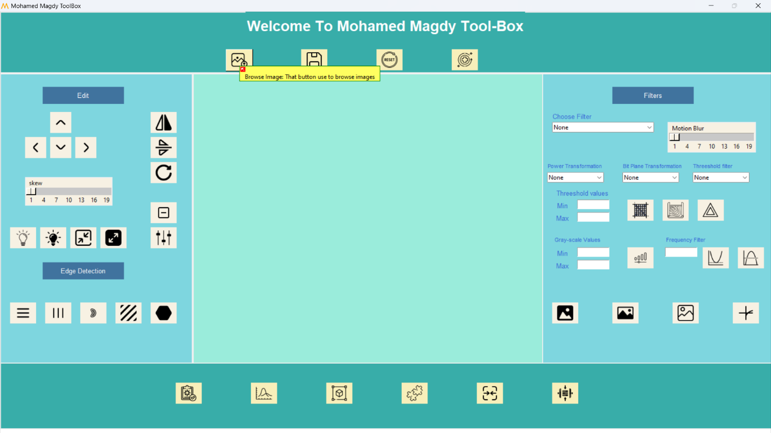

1. Save image

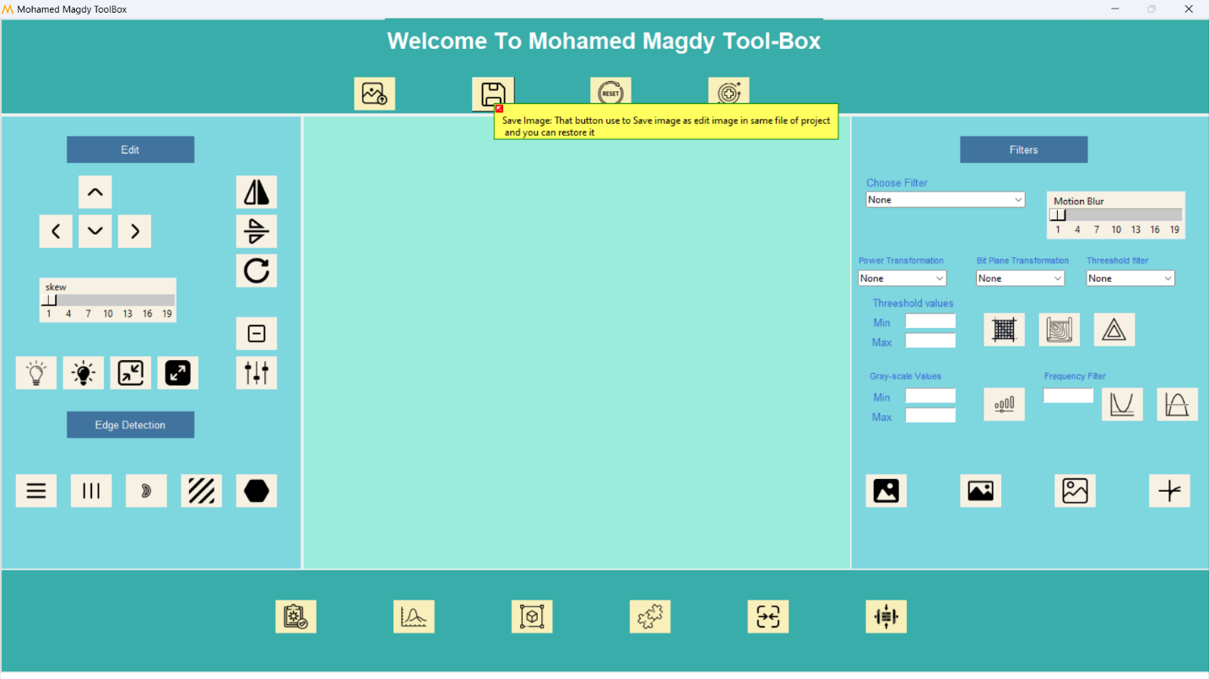

1. Reset Image to the first upload view

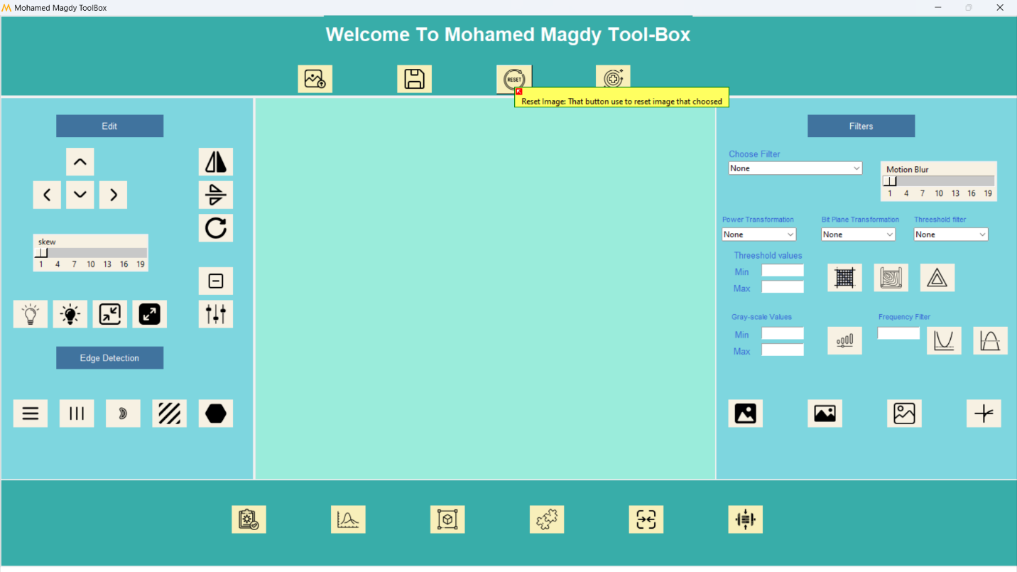

1. Restore Image after Saving it

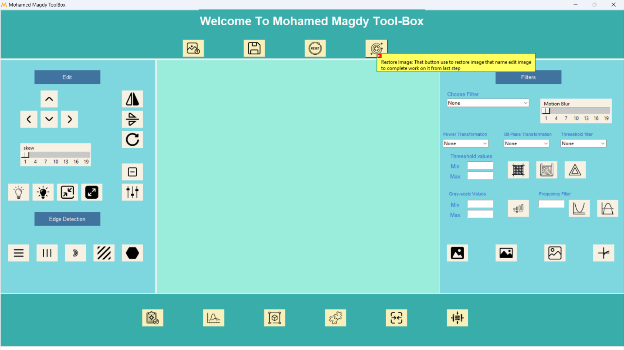

Edit part

1. Translate up & down and left & right

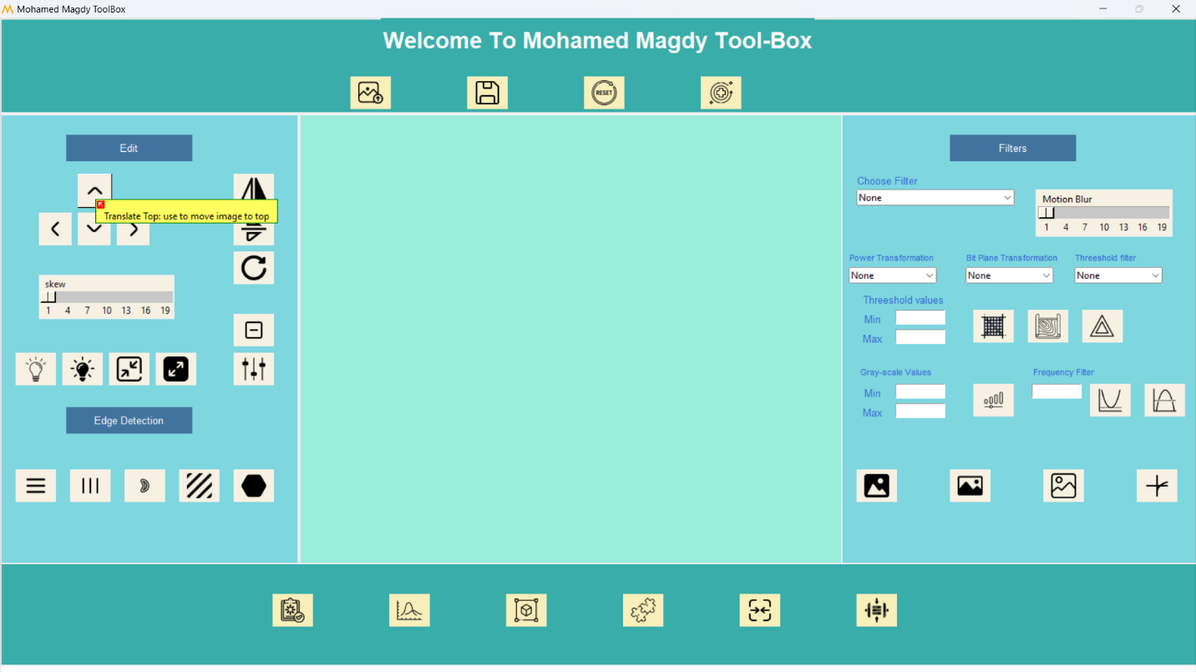

1. Flip Vertical

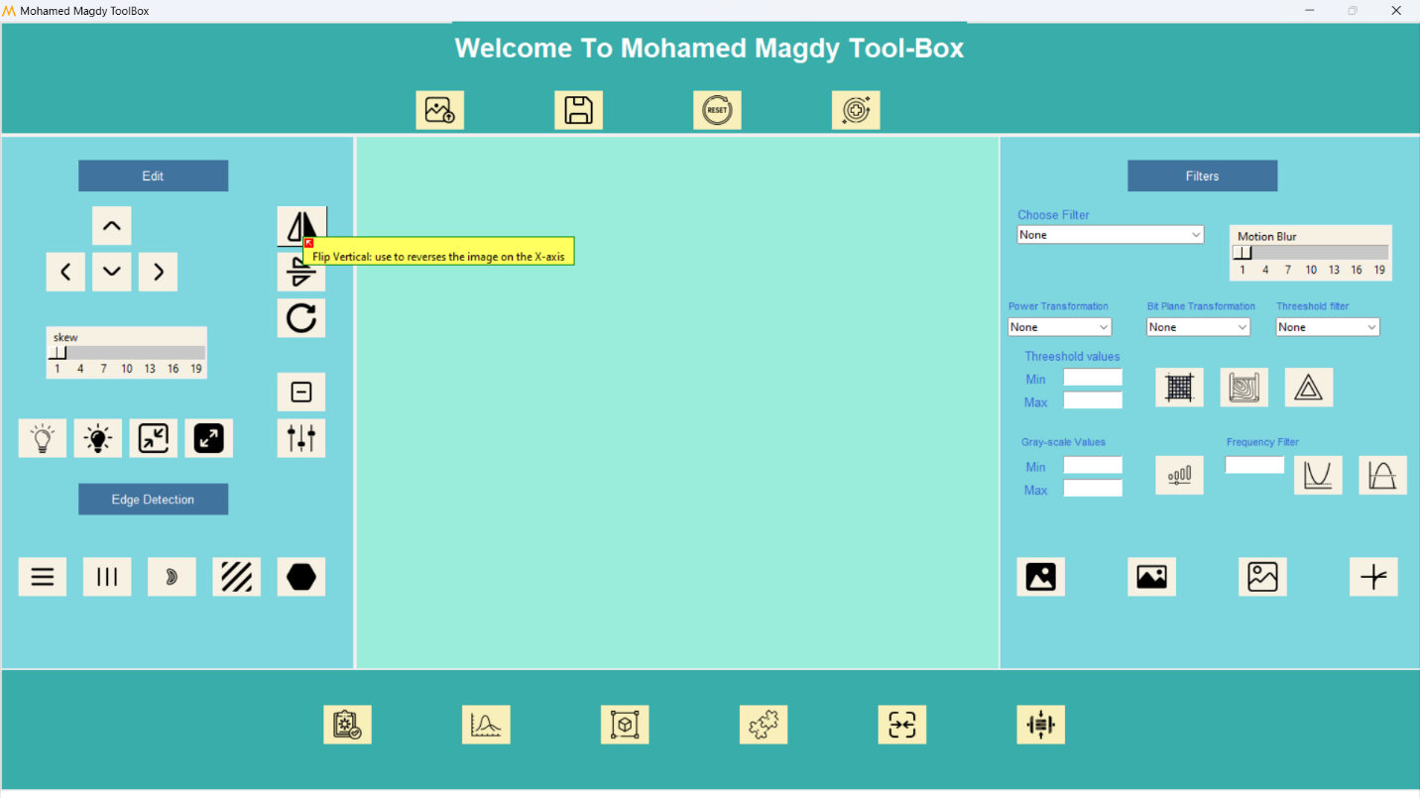

1. Flip horizontal

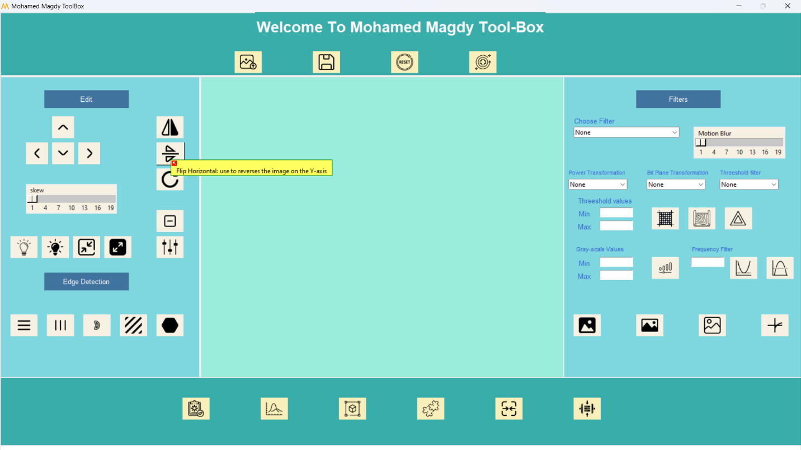

1. Rotate the Image

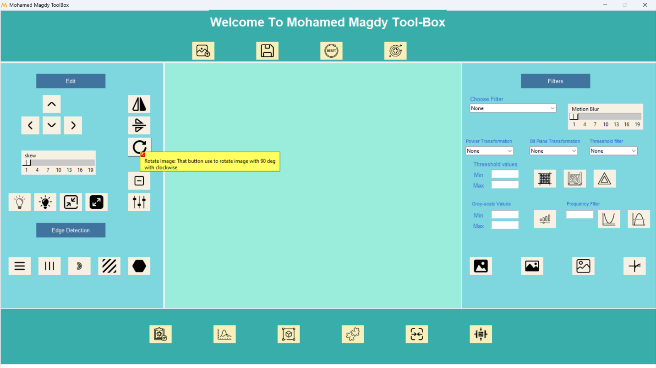

1. Skewing the image

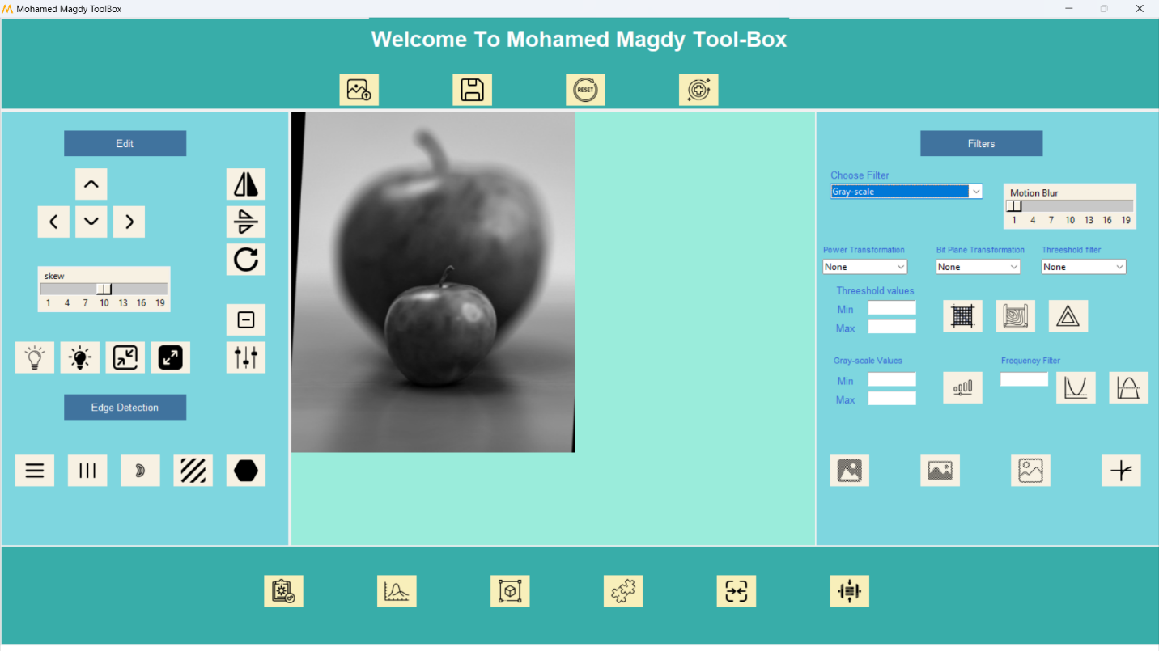

1. Increase the brightness

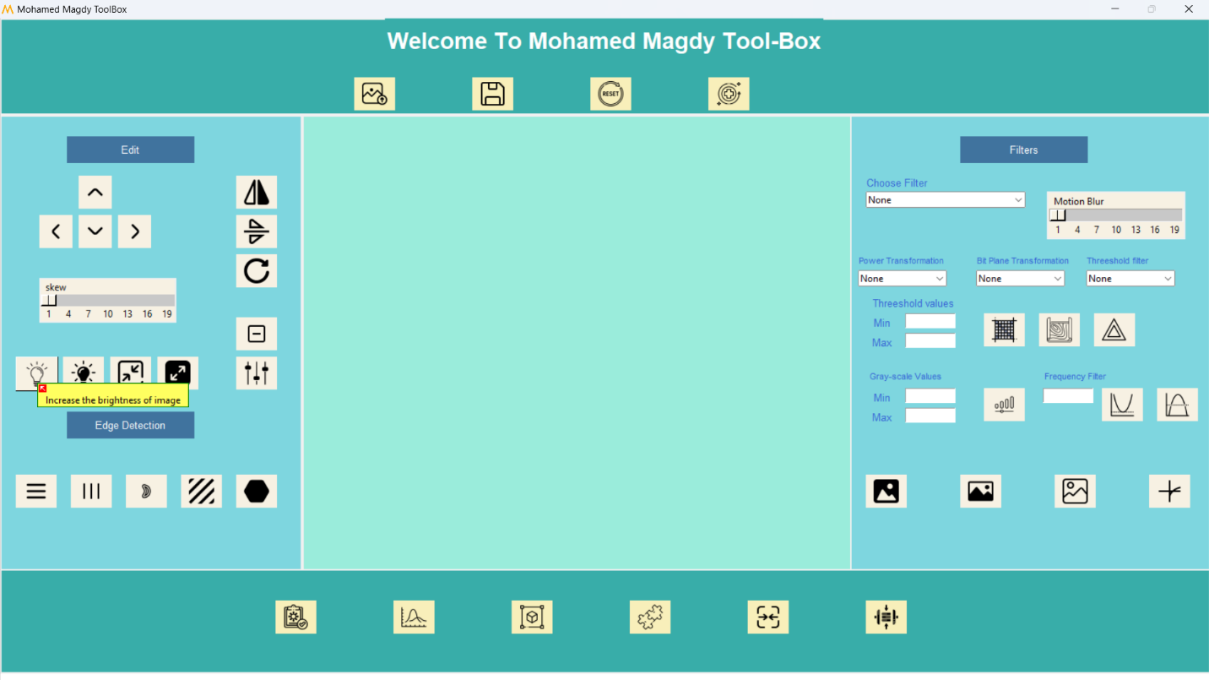

1. Decrease brightness

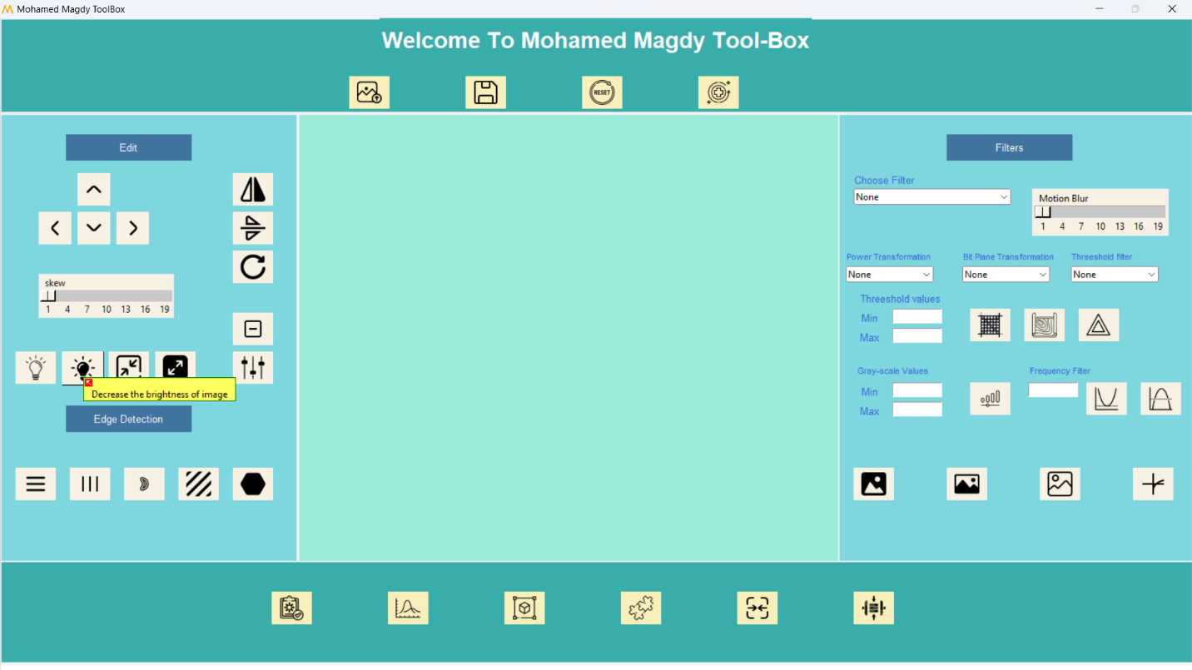

1. Minimize the image

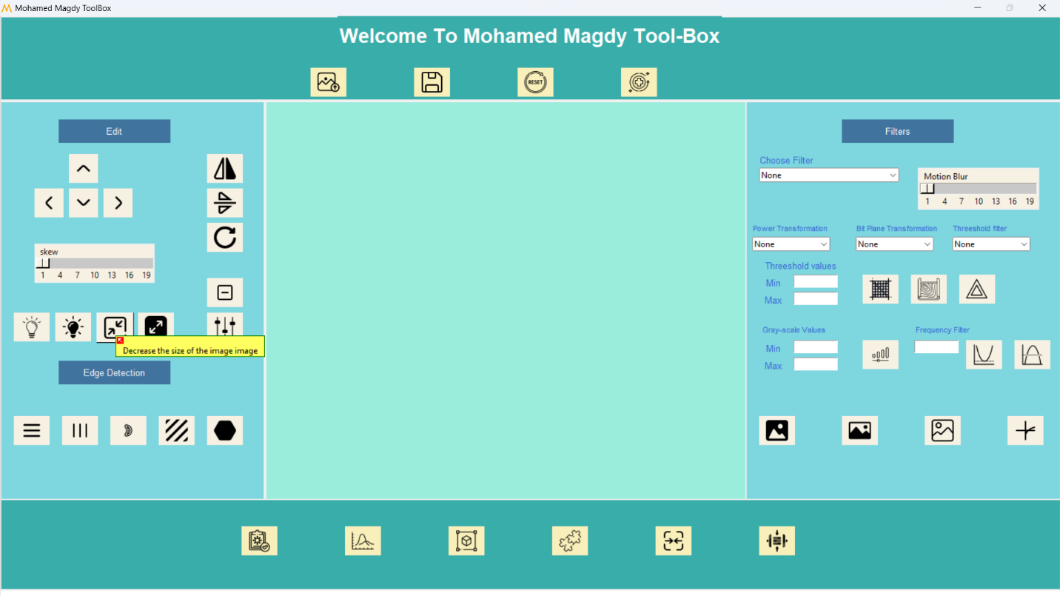

1. Doubling the size of image

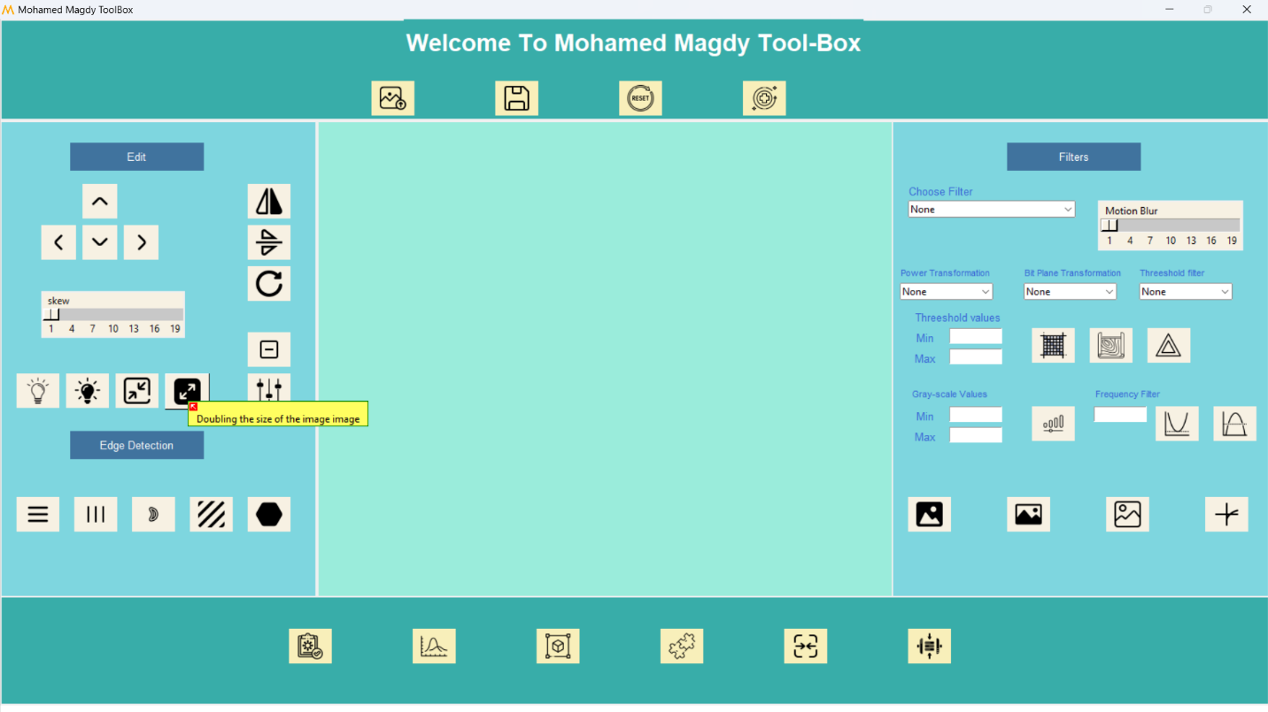

1. Negative the image

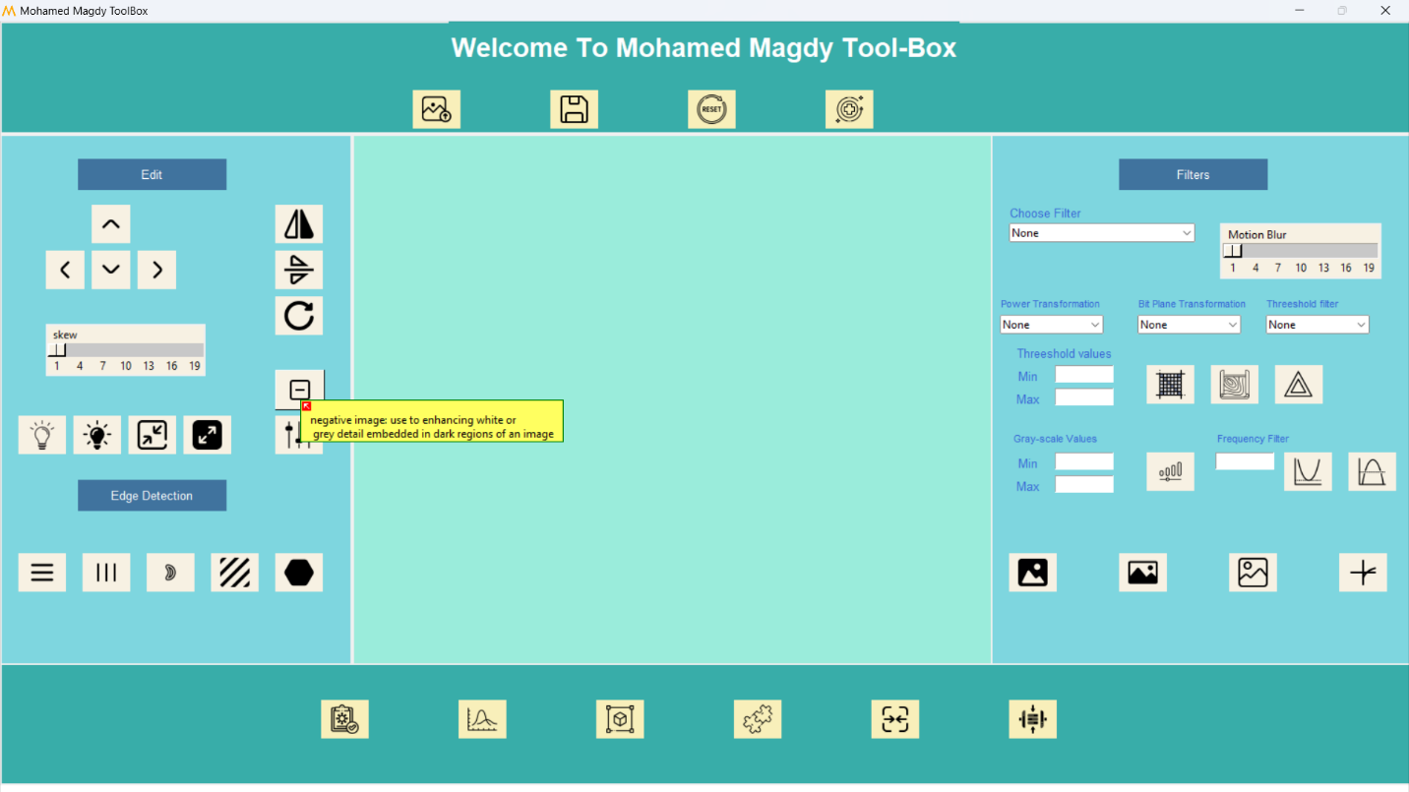

1. Histogram equalization

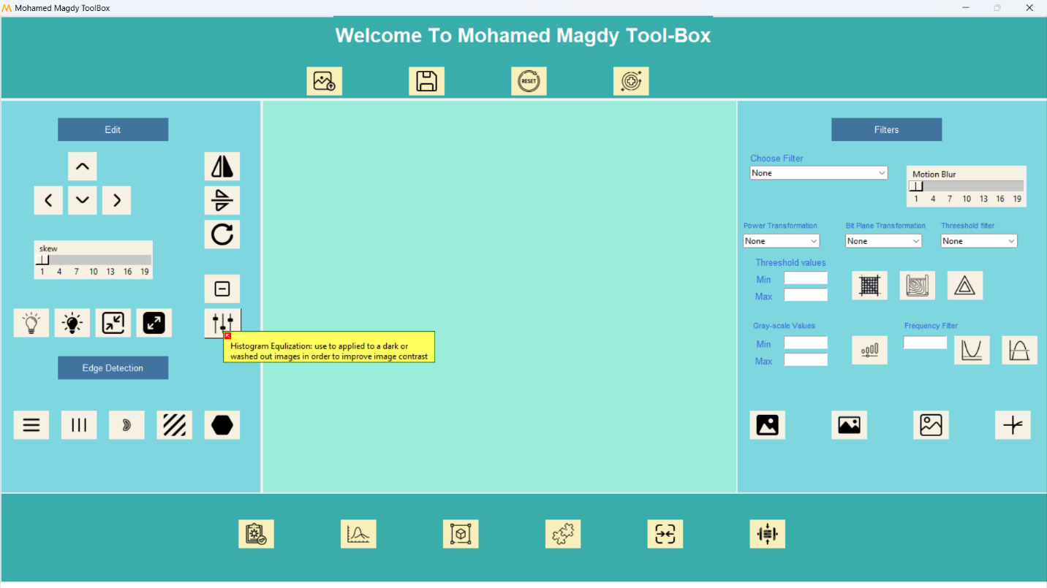

Edge detection part

1. Sobel edge horizontal

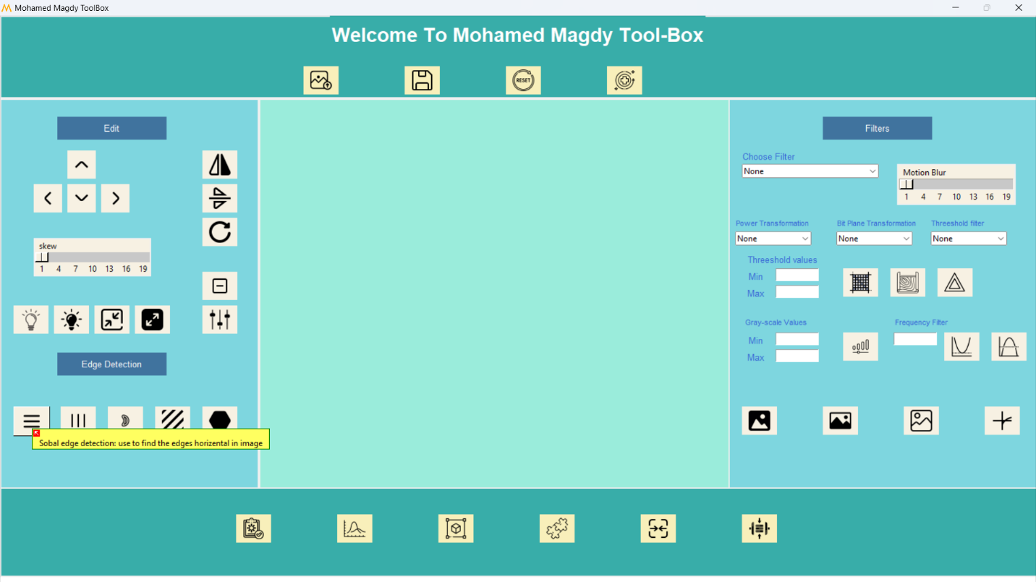

1. Sobel edge vertical

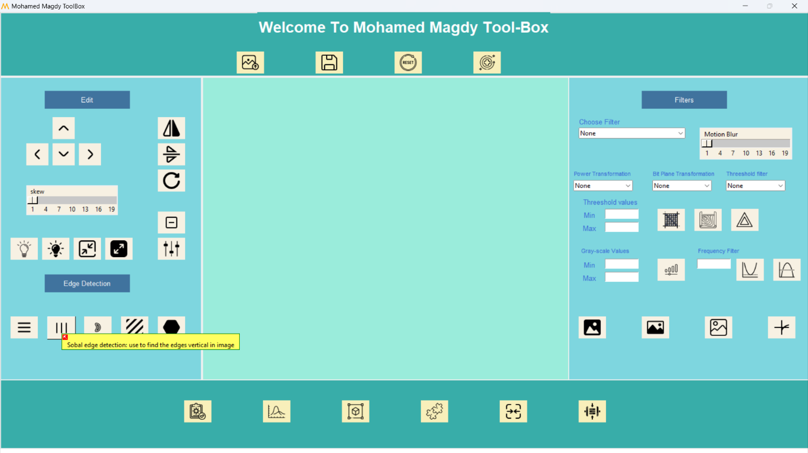

1. Laplacian edge

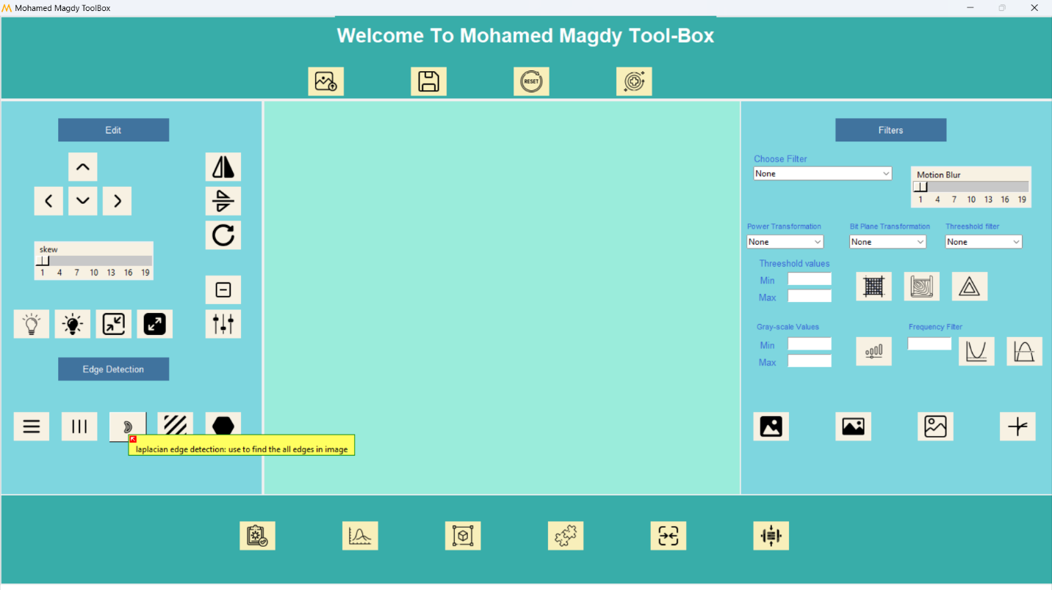

1. Diagonal Sobel

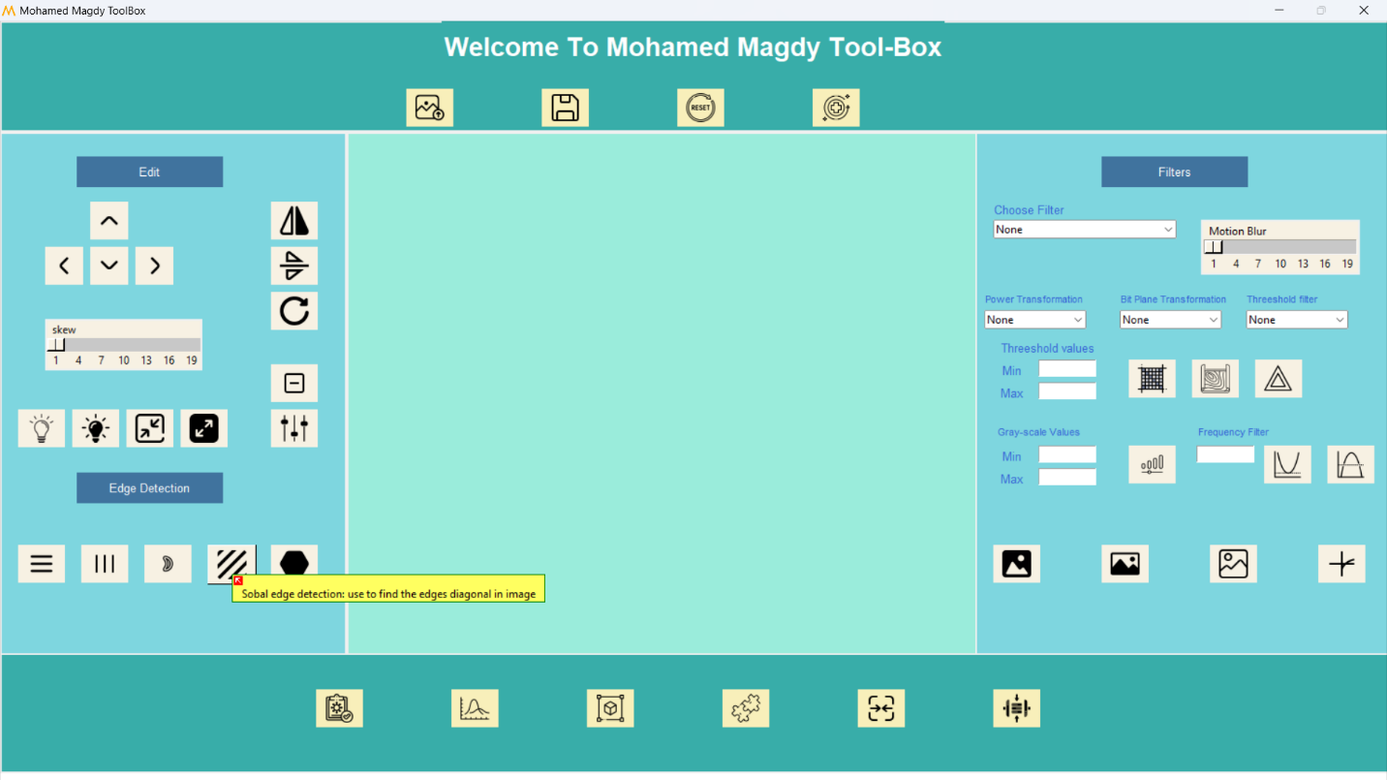

1. Full Sobel

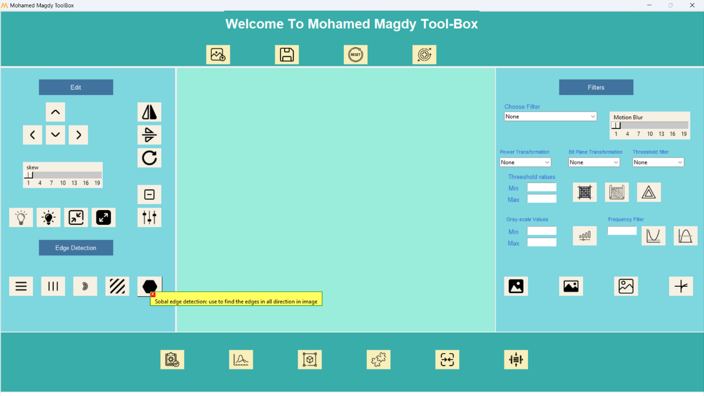

Filter part

1. All available filters (gray scale, blur 3X3, blur 5X5, Motion blur, Gaussian filter, Median blur, bilateral filter, sharping) and scale to Motion blur filter.

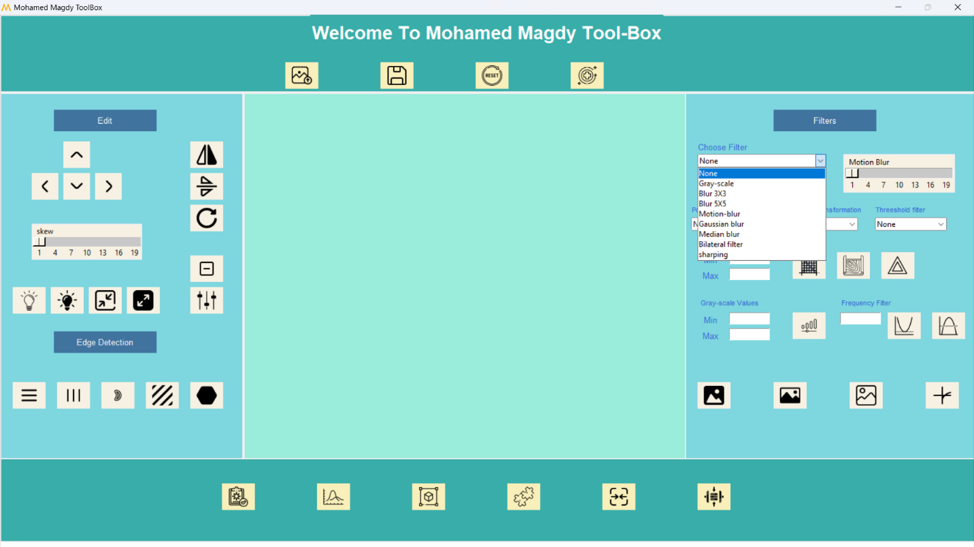

1. Power transformation filter by values (0.1,0.5,1.2,2.2)

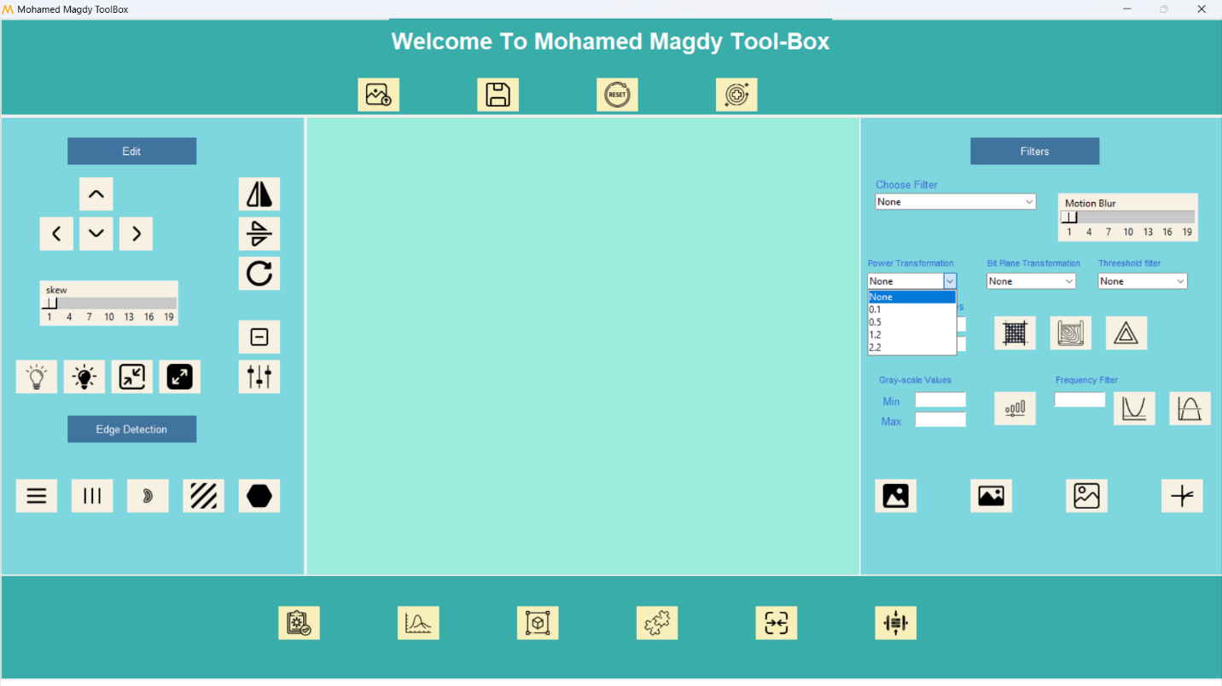

1. Bit plane filter with values (128,64,32,16,8,4,2,1)

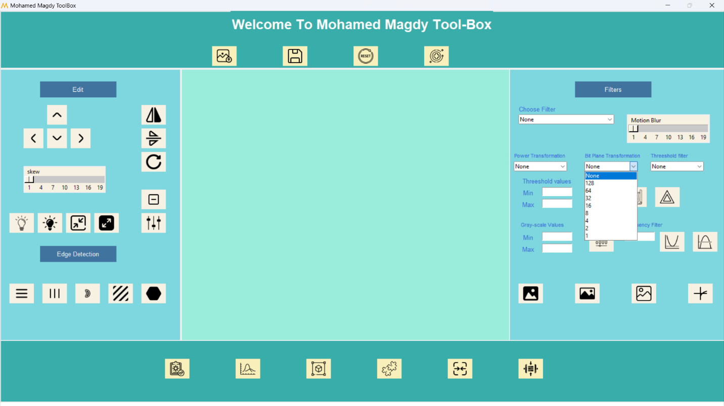

1. Threshold filter with values(dilation , erosion, opening, closing, gradient, top hat, black hat)

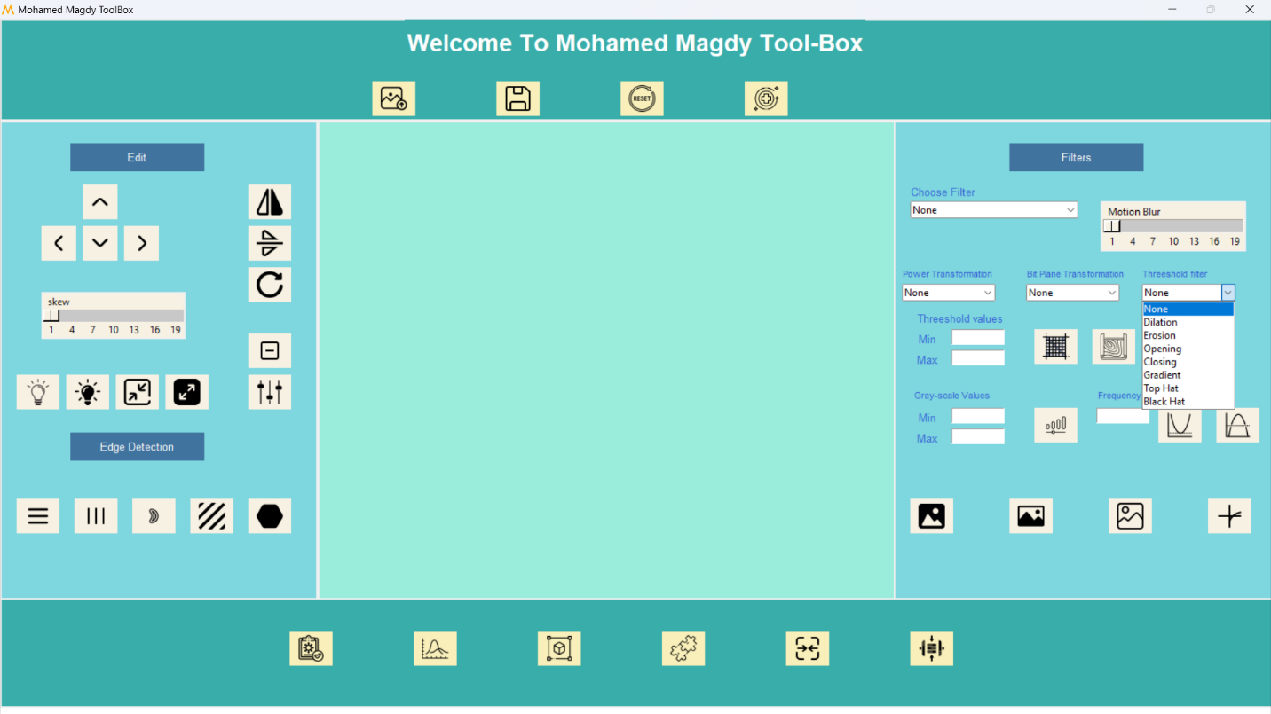

1. Threshold with min and max value

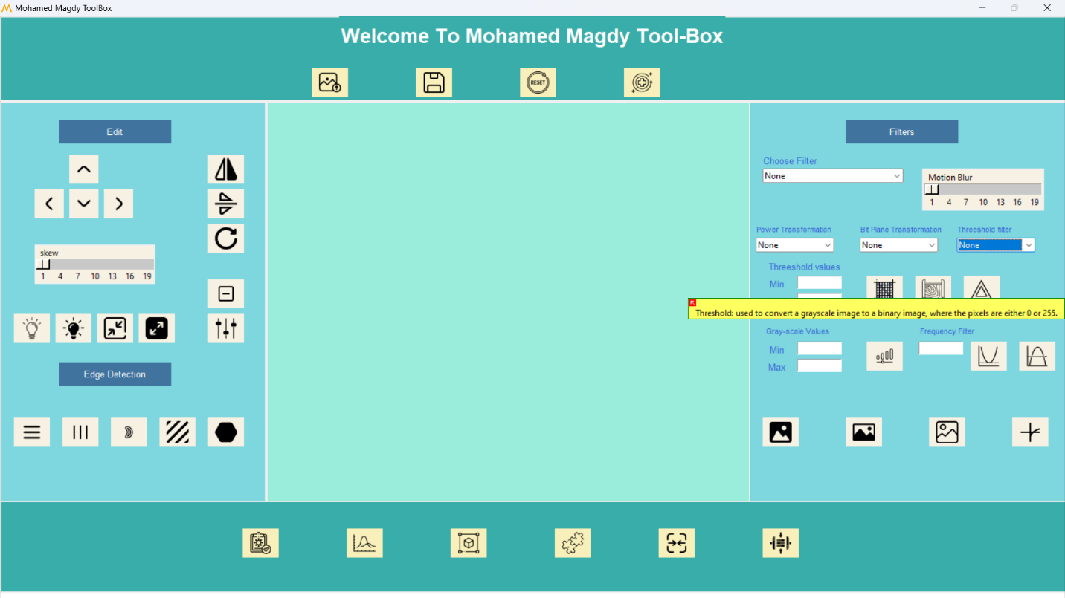

1. Contour

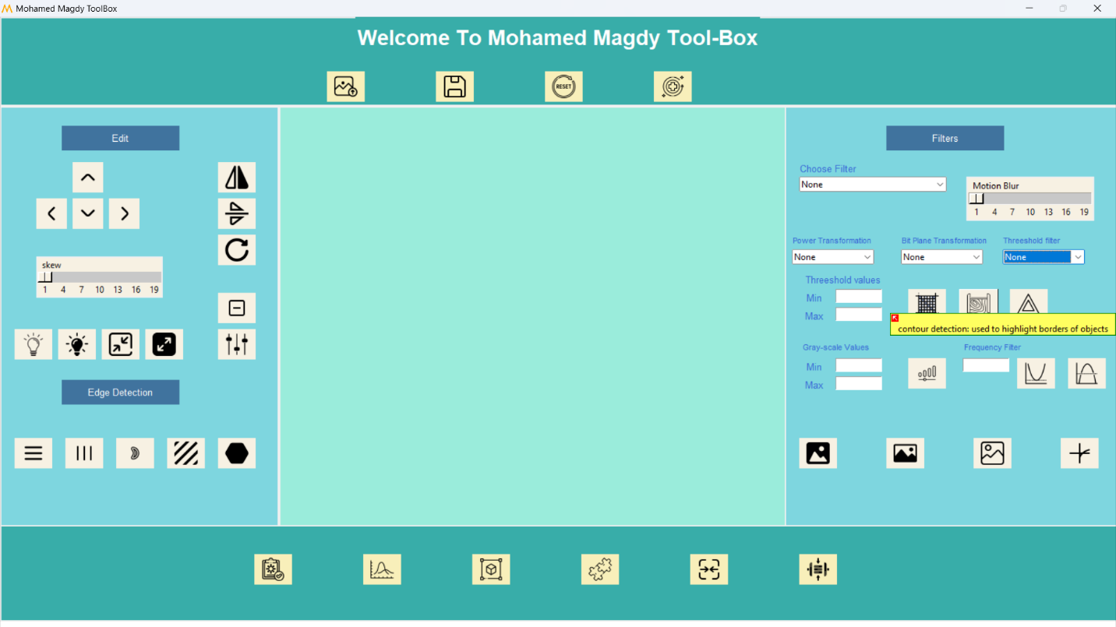

1. Canny edge

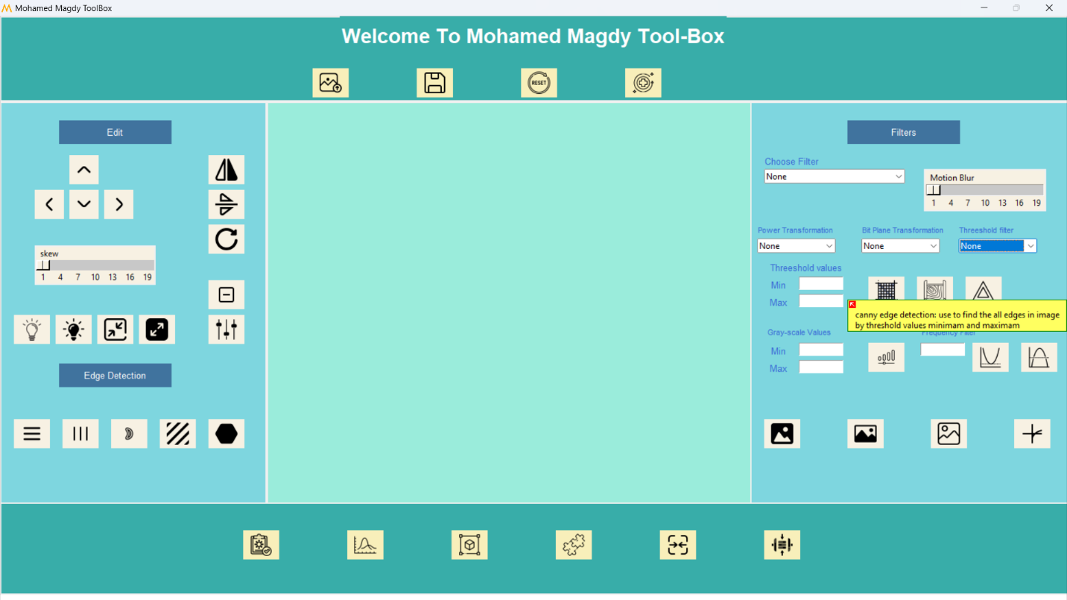

1. Gray level

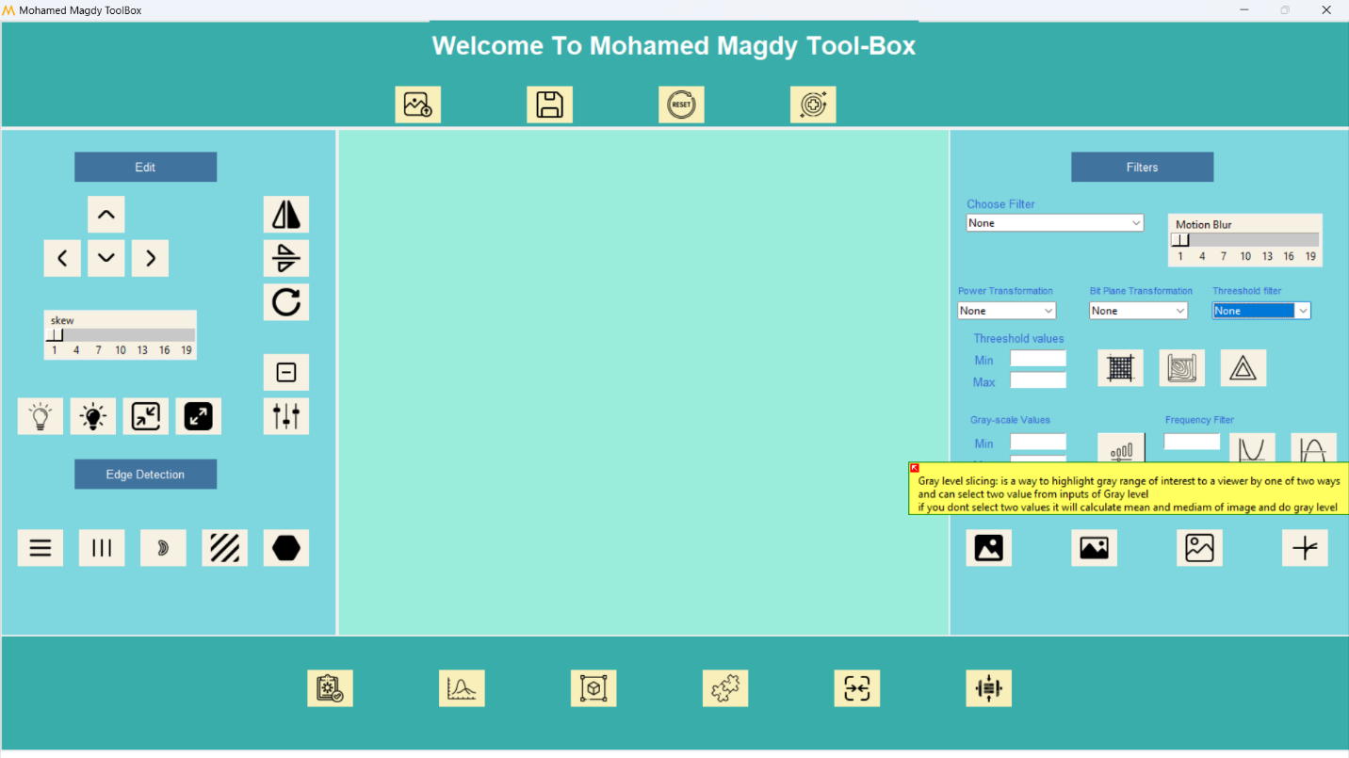

1. Low pass filter

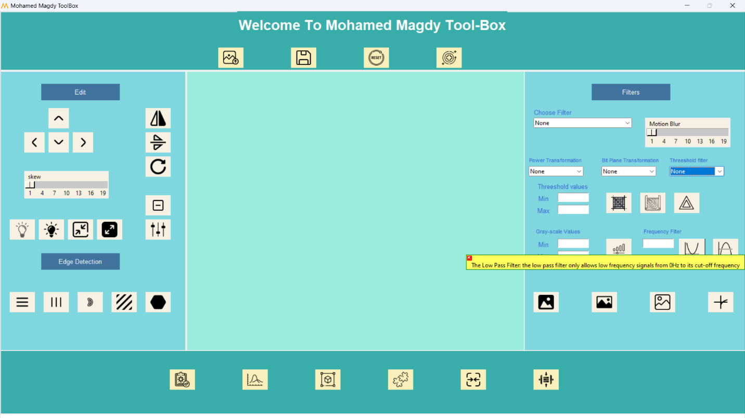

1. High pass filter

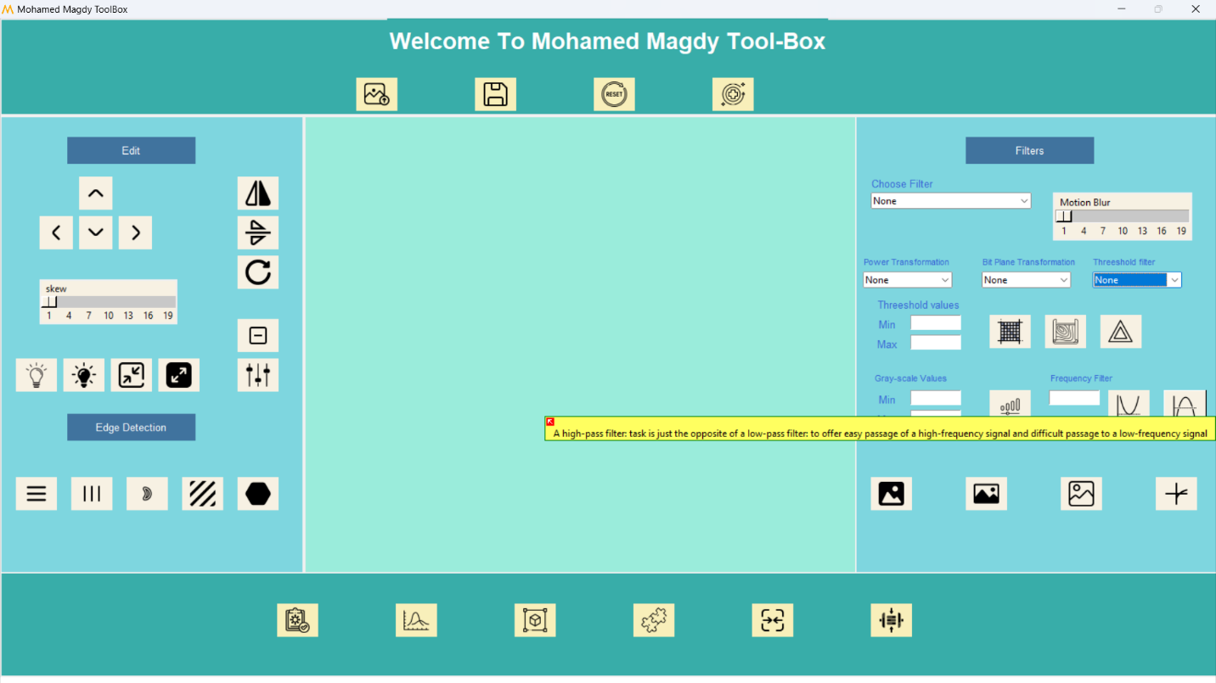

1. Log filter

1. Low sharping

1. Medium sharping

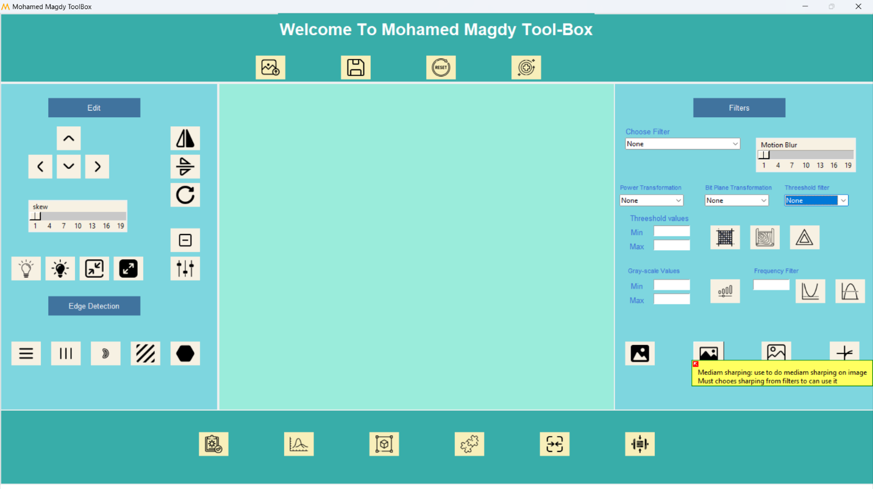

1. High sharping

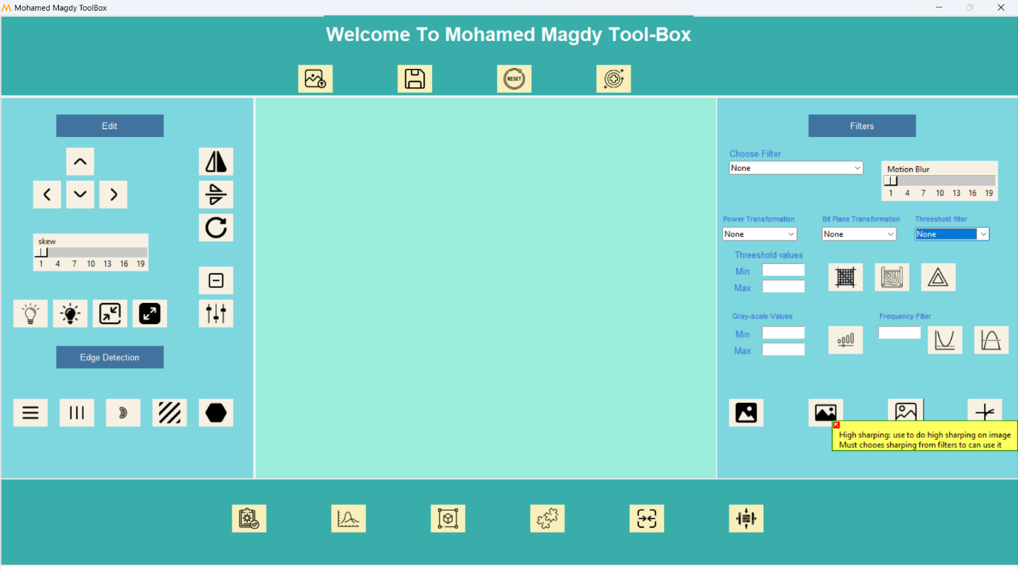

1. Test the image

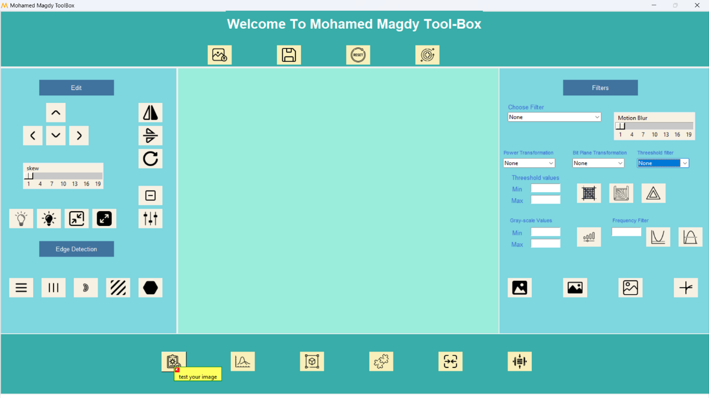

1. Histogram plot

1. Shape detection

1. Matches two images

1. Merge two images

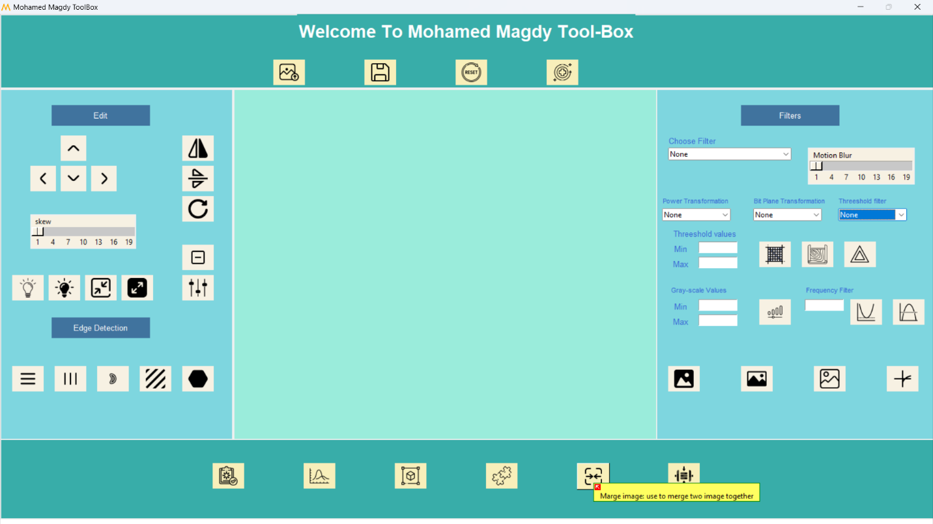

1. DCT Compression loosely way

1. Huffman compression is lossless way

End of Documentation.